**PROGRAM 1:**

**MainActivity.java**

package com.example.expr1;

import android.graphics.Color;

//import android.support.v7.app.AppCompatActivity;

import android.os.Bundle;

import android.view.View;

import android.widget.Button;

import android.widget.TextView;

import androidx.appcompat.app.AppCompatActivity;

public class MainActivity extends AppCompatActivity

{

int ch=1;

float font=30;

@Override

protected void onCreate(Bundle savedInstanceState)

{

super.onCreate(savedInstanceState);

setContentView(R.layout.activity_main);

final TextView t= (TextView) findViewById(R.id.textView);

Button b1= (Button) findViewById(R.id.button1);

b1.setOnClickListener(new View.OnClickListener() {

@Override

public void onClick(View v) {

t.setTextSize(font);

font = font + 5;

if (font == 50)

font = 30;

}

});

Button b2= (Button) findViewById(R.id.button2);

b2.setOnClickListener(new View.OnClickListener() {

@Override

public void onClick(View v) {

switch (ch) {

case 1:

t.setTextColor(Color.RED);

break;

case 2:

t.setTextColor(Color.GREEN);

break;

case 3:

t.setTextColor(Color.BLUE);

break;

case 4:

t.setTextColor(Color.CYAN);

break;

case 5:

t.setTextColor(Color.YELLOW);

break;

case 6:

t.setTextColor(Color.MAGENTA);

break;

}

ch++;

if (ch == 7)

ch = 1;

}

});

}}

**activity_main.xml**

<?xml version="1.0" encoding="utf-8"?>

<LinearLayout xmlns:android="http://schemas.android.com/apk/res/android"

android:orientation="vertical"

android:layout_width="match_parent"

android:layout_height="match_parent">

<TextView

android:id="@+id/textView"

android:layout_width="match_parent"

android:layout_height="wrap_content"

android:layout_margin="30dp"

android:gravity="center"

android:text="Hello World!"

android:textSize="25sp"

android:textStyle="bold" />

<Button

android:id="@+id/button1"

android:layout_width="match_parent"

android:layout_height="wrap_content"

android:layout_margin="20dp"

android:gravity="center"

android:text="Change font size"

android:textSize="25sp" />

<Button

android:id="@+id/button2"

android:layout_width="match_parent"

android:layout_height="wrap_content"

android:layout_margin="20dp"

android:gravity="center"

android:text="Change color"

android:textSize="25sp" />

</LinearLayout>

**OUTPUT:**

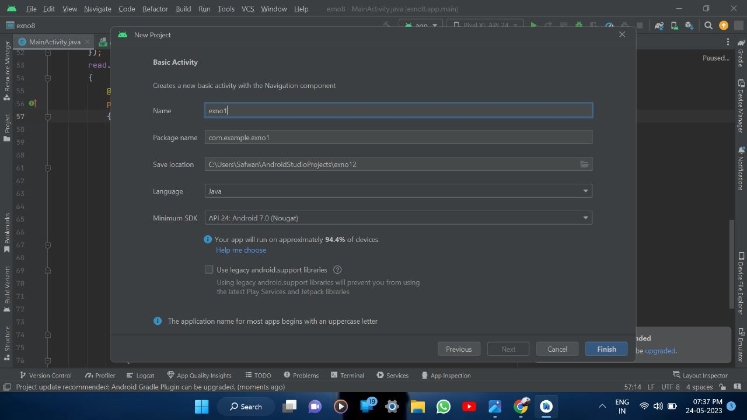

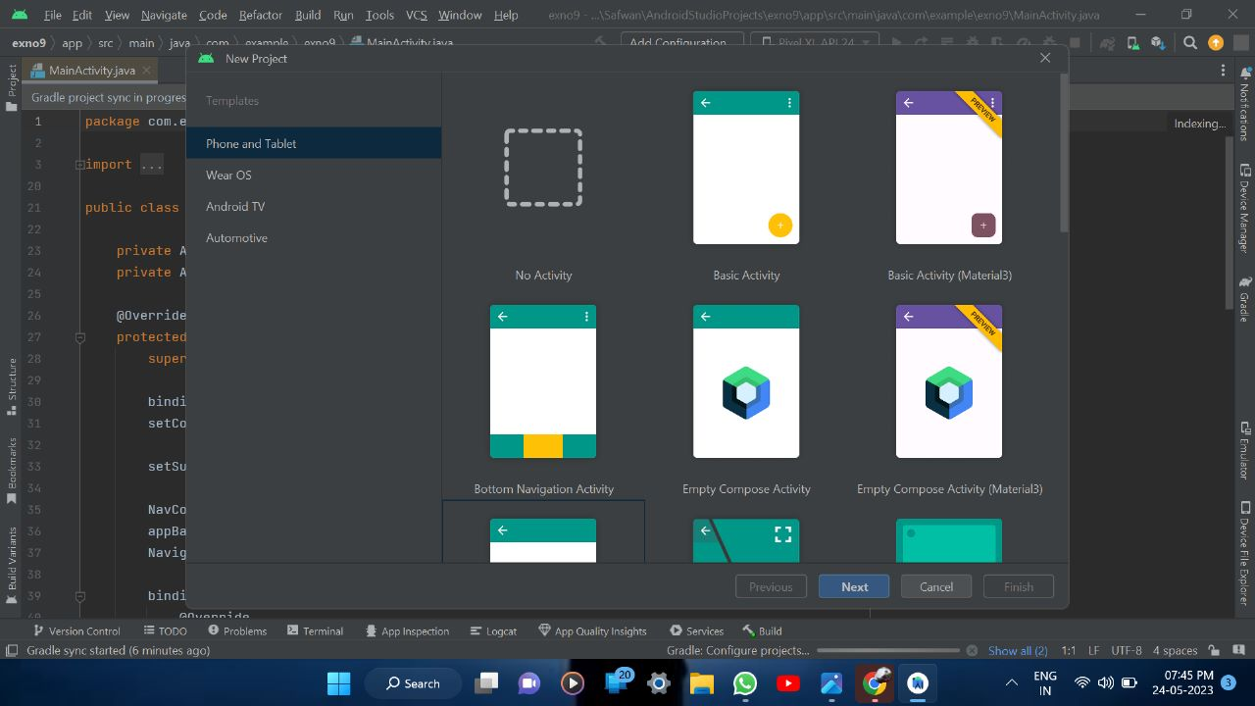

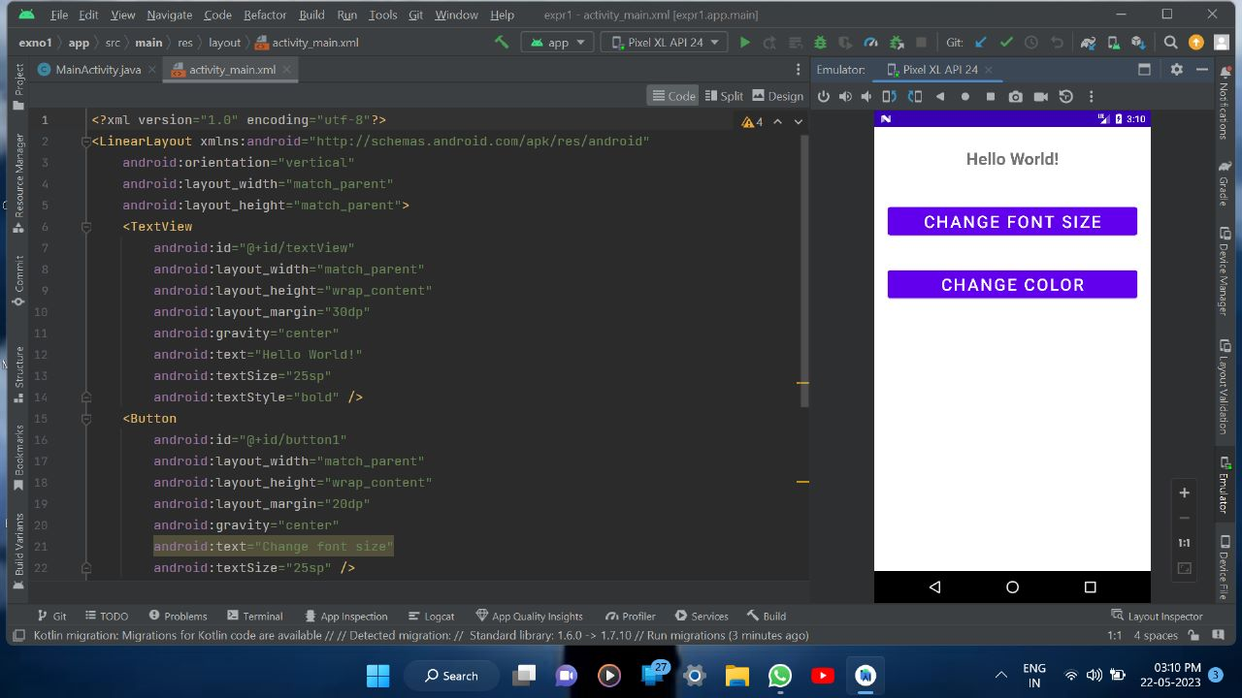

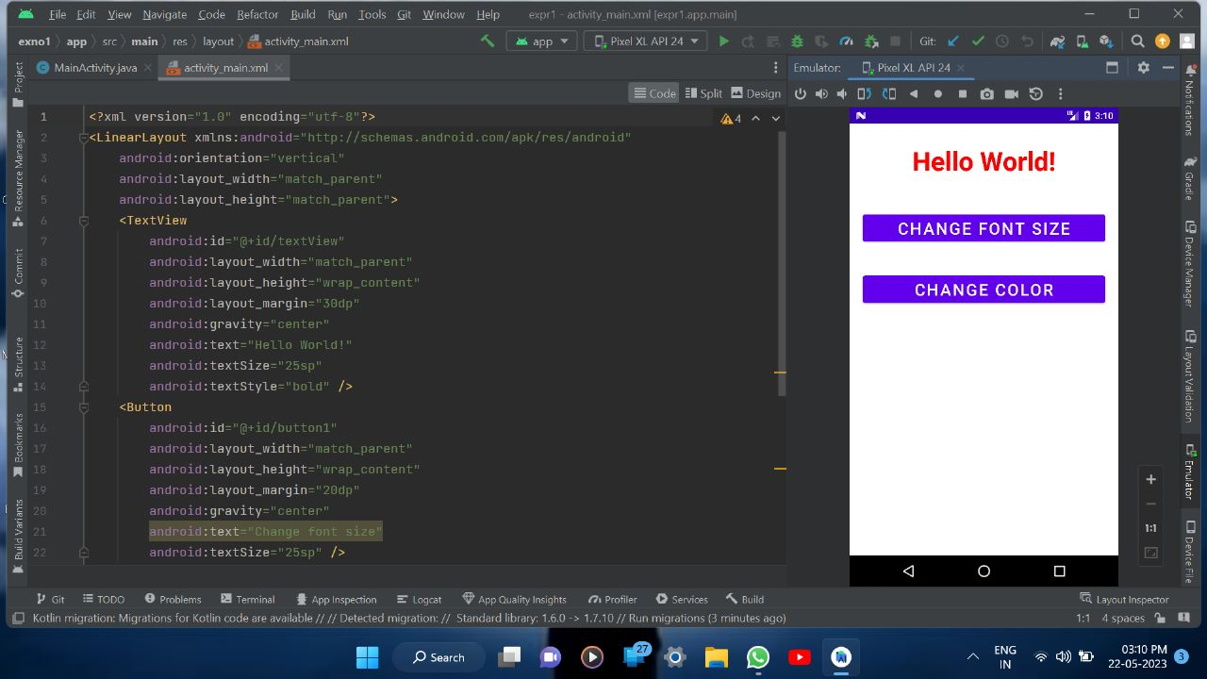

**RESULT:**

Thus a simple Android Application that uses Gui components, fonts and color is designed Implemented and executed sucessfully

**PROGRAM 2:**

**MainActivity.java**

package com.example.exno2;

import android.content.Intent;

import android.os.Bundle;

import android.view.View;

import android.widget.ArrayAdapter;

import android.widget.Button;

import android.widget.EditText;

import android.widget.Spinner;

import androidx.appcompat.app.AppCompatActivity;

public class MainActivity extends AppCompatActivity {

//Defining the Views

EditText e1,e2;

Button bt;

Spinner s;

//Data for populating in Spinner

String [] dept_array={"CSE","ECE","IT","Mech","Civil"};

String name,reg,dept;

@Override

protected void onCreate(Bundle savedInstanceState) {

super.onCreate(savedInstanceState);

setContentView(R.layout.activity_main);

//Referring the Views

e1= (EditText) findViewById(R.id.editText);

e2= (EditText) findViewById(R.id.editText2);

bt= (Button) findViewById(R.id.button);

s= (Spinner) findViewById(R.id.spinner);

//Creating Adapter for Spinner for adapting the data from array to

Spinner

ArrayAdapter adapter= new

ArrayAdapter(MainActivity.this,android.R.layout.simple_spinner_item,de

pt_array);

s.setAdapter(adapter);

//Creating Listener for Button

bt.setOnClickListener(new View.OnClickListener() {

@Override

public void onClick(View v) {

//Getting the Values from Views(Edittext & Spinner)

name=e1.getText().toString();

reg=e2.getText().toString();

dept=s.getSelectedItem().toString();

//Intent For Navigating to Second Activity

Intent i = new Intent(MainActivity.this,SecondActivity.class);

//For Passing the Values to Second Activity

i.putExtra("name_key", name);

i.putExtra("reg_key",reg);

i.putExtra("dept_key", dept);

startActivity(i);

} }); }}

**SecondActivity.java**

package com.example.exno2;

import android.content.Intent;

//import android.support.v7.app.AppCompatActivity;

import android.os.Bundle;

import android.widget.TextView;

import androidx.appcompat.app.AppCompatActivity;

public class SecondActivity extends AppCompatActivity {

TextView t1,t2,t3; String name,reg,dept;

@Override

protected void onCreate(Bundle savedInstanceState) {

super.onCreate(savedInstanceState);

setContentView(R.layout.activity_second);

t1= (TextView) findViewById(R.id.textView1);

t2= (TextView) findViewById(R.id.textView2);

t3= (TextView) findViewById(R.id.textView3);

//Getting the Intent

Intent i = getIntent();

//Getting the Values from First Activity using the Intent received

name=i.getStringExtra("name_key");

reg=i.getStringExtra("reg_key");

dept=i.getStringExtra("dept_key");

//Setting the Values to Intent

t1.setText(name);

t2.setText(reg);

t3.setText(dept); }}

**activity_main.xml**

<?xml version="1.0" encoding="utf-8"?>

<RelativeLayout xmlns:android="http://schemas.android.com/apk/res/android"

xmlns:tools="http://schemas.android.com/tools"

android:layout_width="match_parent"

android:layout_height="match_parent"

tools:context=".MainActivity">

<LinearLayout

android:layout_width="match_parent"

android:layout_height="100dp">

<TextView

android:id="@+id/textView"

android:layout_width="match_parent"

android:layout_height="wrap_content"

android:layout_margin="30dp"

android:text="Details Form"

android:textSize="25sp"

android:gravity="center"/>

</LinearLayout>

<GridLayout

android:id="@+id/gridLayout"

android:layout_width="match_parent"

android:layout_height="match_parent"

android:layout_marginTop="100dp"

android:layout_marginBottom="200dp"

android:columnCount="2"

android:rowCount="3">

<TextView

android:id="@+id/textView1"

android:layout_width="wrap_content"

android:layout_height="wrap_content"

android:layout_margin="10dp"

android:layout_row="0"

android:layout_column="0"

android:text="Name"

android:textSize="20sp"

android:gravity="center"/>

<EditText

android:id="@+id/editText"

android:layout_width="wrap_content"

android:layout_height="wrap_content"

android:layout_margin="10dp"

android:layout_row="0"

android:layout_column="1"

android:ems="10"/>

<TextView

android:id="@+id/textView2"

android:layout_width="wrap_content"

android:layout_height="wrap_content"

android:layout_margin="10dp"

android:layout_row="1"

android:layout_column="0"

android:text="Reg.No"

android:textSize="20sp"

android:gravity="center"/>

<EditText

android:id="@+id/editText2"

android:layout_width="wrap_content"

android:layout_height="wrap_content"

android:layout_margin="10dp"

android:layout_row="1"

android:layout_column="1"

android:inputType="number"

android:ems="10"/>

<TextView

android:id="@+id/textView3"

android:layout_width="wrap_content"

android:layout_height="wrap_content"

android:layout_margin="10dp"

android:layout_row="2"

android:layout_column="0"

android:text="Dept"

android:textSize="20sp"

android:gravity="center"/>

<Spinner

android:id="@+id/spinner"

android:layout_width="wrap_content"

android:layout_height="wrap_content"

android:layout_margin="10dp"

android:layout_row="2"

android:layout_column="1"

android:spinnerMode="dropdown"/>

</GridLayout>

<Button

android:id="@+id/button"

android:layout_width="wrap_content"

android:layout_height="wrap_content"

android:layout_alignParentBottom="true"

android:layout_centerInParent="true"

android:layout_marginBottom="150dp"

android:text="Submit"/>

</RelativeLayout>

**activity_second.xml**

<?xml version="1.0" encoding="utf-8"?>

<LinearLayout xmlns:android="http://schemas.android.com/apk/res/android"

xmlns:tools="http://schemas.android.com/tools"

android:layout_width="match_parent"

android:layout_height="match_parent"

tools:context="com.example.exno2.SecondActivity"

android:orientation="vertical"

android:gravity="center">

<TextView

android:id="@+id/textView1"

android:layout_width="wrap_content"

android:layout_height="wrap_content"

android:layout_margin="20dp"

android:text="New Text"

android:textSize="30sp"/>

<TextView

android:id="@+id/textView2"

android:layout_width="wrap_content"

android:layout_height="wrap_content"

android:layout_margin="20dp"

android:text="New Text"

android:textSize="30sp"/>

<TextView

android:id="@+id/textView3"

android:layout_width="wrap_content"

android:layout_height="wrap_content"

android:layout_margin="20dp"

android:text="New Text"

android:textSize="30sp"/>

</LinearLayout>

**OUTPUT**

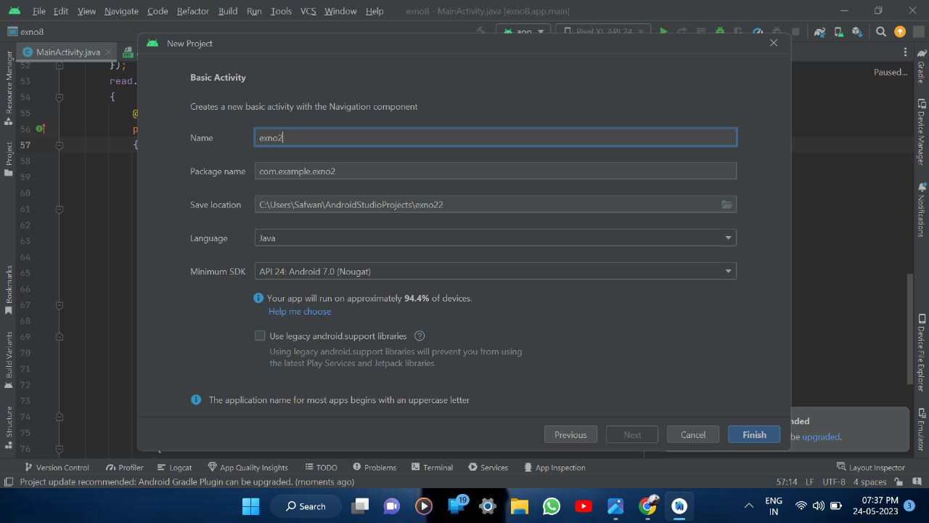



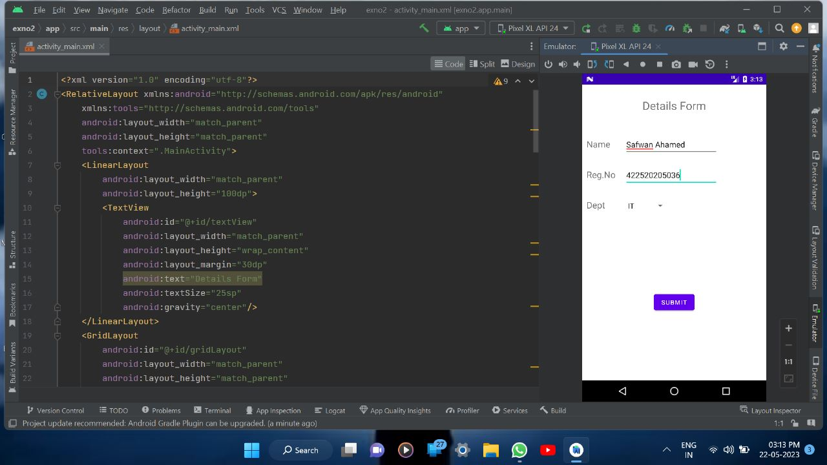

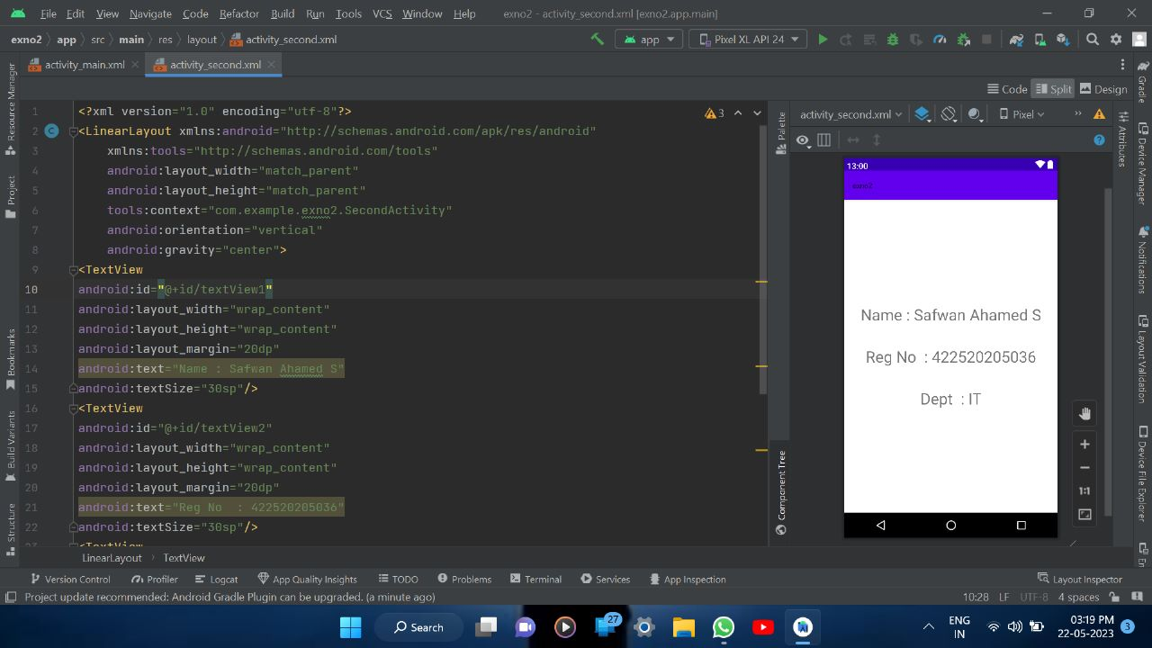

**RESULT**

Thus a simple Android Application that uses Layout manager and event listner is designed Implemented and executed sucessfully

**PROGRAM 3:**

**MainActivity.java**

package com.example.exno3;

import android.app.Activity;

import android.graphics.Bitmap;

import android.graphics.Canvas;

import android.graphics.Color;

import android.graphics.Paint;

import android.graphics.drawable.BitmapDrawable;

import android.os.Bundle;

import android.widget.ImageView;

public class MainActivity extends Activity

{

@Override

public void onCreate(Bundle savedInstanceState)

{

super.onCreate(savedInstanceState);

setContentView(R.layout.activity_main);

//Creating a Bitmap

Bitmap bg = Bitmap.createBitmap(720, 1280, Bitmap.Config.ARGB_8888);

//Setting the Bitmap as background for the ImageView

ImageView i = (ImageView) findViewById(R.id.imageView);

i.setBackgroundDrawable(new BitmapDrawable(bg));

//Creating the Canvas Object

Canvas canvas = new Canvas(bg);

//Creating the Paint Object and set its color & TextSize

Paint paint = new Paint();

paint.setColor(Color.BLUE);

paint.setTextSize(50);

//To draw a Rectangle

canvas.drawText("Rectangle", 420, 150, paint);

canvas.drawRect(400, 200, 650, 700, paint);

//To draw a Circle

canvas.drawText("Circle", 120, 150, paint);

canvas.drawCircle(200, 350, 150, paint);

//To draw a Square

canvas.drawText("Square", 120, 800, paint);

canvas.drawRect(50, 850, 350, 1150, paint);

//To draw a Line

canvas.drawText("Line", 480, 800, paint);

canvas.drawLine(520, 850, 520, 1150, paint);

}

}

**activity_main.xml**

<?xml version="1.0" encoding="utf-8"?>

<RelativeLayout xmlns:android="http://schemas.android.com/apk/res/android"

android:layout_width="match_parent"

android:layout_height="match_parent">

<ImageView

android:layout_width="match_parent"

android:layout_height="match_parent"

android:id="@+id/imageView" />

</RelativeLayout>

**OUTPUT**

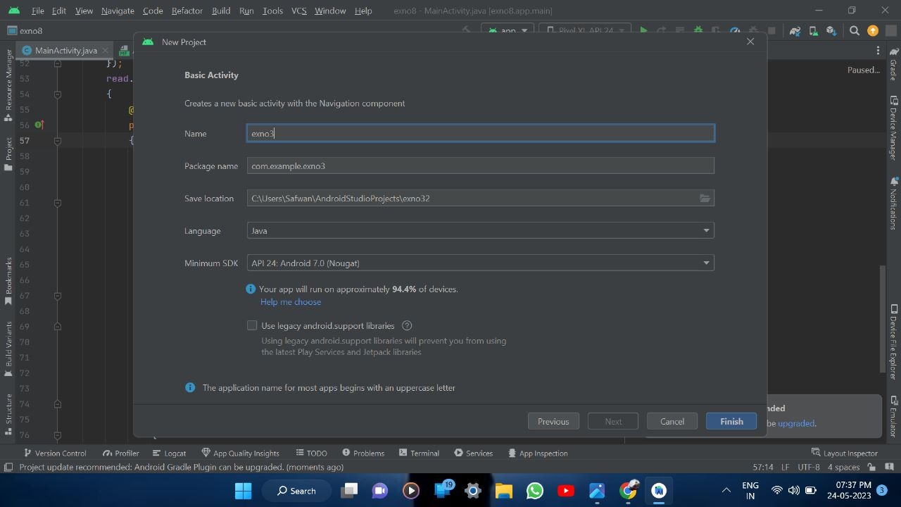



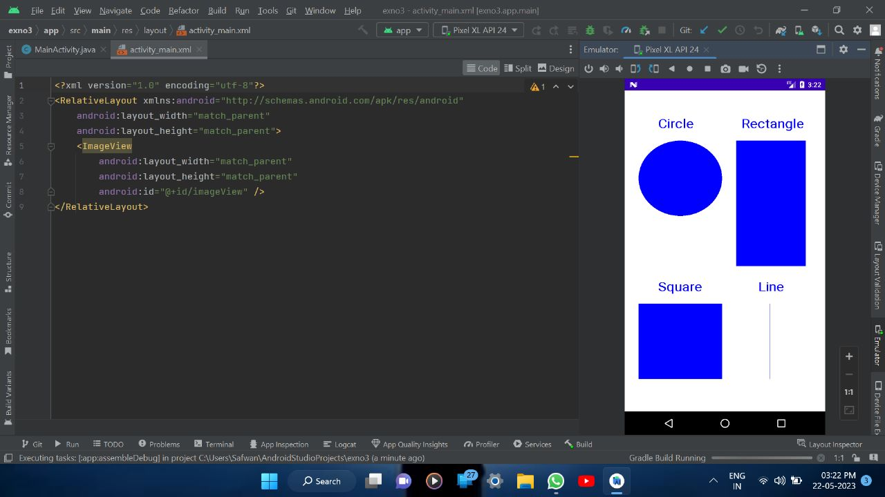

**RESULT:**

Thus a simple Android Application that draws basic graphical primitives on the screen is designed Implemented and executed sucessfully

**PROGRAM 4:**

**MainActivity.java**

package com.example.exno4;

import android.app.Activity;

import android.app.AlertDialog.Builder;

import android.content.Context;

import android.database.Cursor;

import android.database.sqlite.SQLiteDatabase;

import android.os.Bundle;

import android.view.View;

import android.view.View.OnClickListener;

import android.widget.Button;

import android.widget.EditText;

public class MainActivity extends Activity implements OnClickListener

{

EditText Rollno,Name,Marks;

Button Insert,Delete,Update,View,ViewAll;

SQLiteDatabase db;

/** Called when the activity is first created. */

@Override

public void onCreate(Bundle savedInstanceState)

{

super.onCreate(savedInstanceState);

setContentView(R.layout.activity_main);

Rollno=(EditText)findViewById(R.id.Rollno);

Name=(EditText)findViewById(R.id.Name);

Marks=(EditText)findViewById(R.id.Marks);

Insert=(Button)findViewById(R.id.Insert);

Delete=(Button)findViewById(R.id.Delete);

Update=(Button)findViewById(R.id.Update);

View=(Button)findViewById(R.id.View);

ViewAll=(Button)findViewById(R.id.ViewAll);

Insert.setOnClickListener(this);

Delete.setOnClickListener(this);

Update.setOnClickListener(this);

View.setOnClickListener(this);

ViewAll.setOnClickListener(this);

// Creating database and table

db=openOrCreateDatabase("StudentDB", Context.MODE_PRIVATE, null);

db.execSQL("CREATE TABLE IF NOT EXISTS student(rollno VARCHAR,name VARCHAR,marks VARCHAR);");

}

public void onClick(View view)

{

// Inserting a record to the Student table

if(view==Insert)

{

// Checking for empty fields

if(Rollno.getText().toString().trim().length()==0||

Name.getText().toString().trim().length()==0||

Marks.getText().toString().trim().length()==0)

{

showMessage("Error", "Please enter all values");

return;

}

db.execSQL("INSERT INTO student VALUES('"+Rollno.getText()+"','"+Name.getText()+

"','"+Marks.getText()+"');");

showMessage("Success", "Record added");

clearText(); }

// Deleting a record from the Student table

if(view==Delete)

{

// Checking for empty roll number

if(Rollno.getText().toString().trim().length()==0)

{

showMessage("Error", "Please enter Rollno");

return;

}

Cursor c=db.rawQuery("SELECT * FROM student WHERE rollno='"+Rollno.getText()+"'", null);

if(c.moveToFirst())

{

db.execSQL("DELETE FROM student WHERE rollno='"+Rollno.getText()+"'");

showMessage("Success", "Record Deleted");

}

else

{

showMessage("Error", "Invalid Rollno");

}

clearText();

}

// Updating a record in the Student table

if(view==Update)

{

// Checking for empty roll number

if(Rollno.getText().toString().trim().length()==0)

{

showMessage("Error", "Please enter Rollno");

return;

}

Cursor c=db.rawQuery("SELECT * FROM student WHERE rollno='"+Rollno.getText()+"'", null);

if(c.moveToFirst()) {

db.execSQL("UPDATE student SET name='" + Name.getText() + "',marks='" + Marks.getText() +

"' WHERE rollno='"+Rollno.getText()+"'");

showMessage("Success", "Record Modified");

}

else {

showMessage("Error", "Invalid Rollno");

}

clearText();

}

// Display a record from the Student table

if(view==View)

{

// Checking for empty roll number

if(Rollno.getText().toString().trim().length()==0)

{

showMessage("Error", "Please enter Rollno");

return;

}

Cursor c=db.rawQuery("SELECT * FROM student WHERE rollno='"+Rollno.getText()+"'", null);

if(c.moveToFirst())

{

Name.setText(c.getString(1));

Marks.setText(c.getString(2));

}

else

{

showMessage("Error", "Invalid Rollno");

clearText();

}

}

// Displaying all the records

if(view==ViewAll)

{

Cursor c=db.rawQuery("SELECT * FROM student", null);

if(c.getCount()==0)

{

showMessage("Error", "No records found");

return;

}

StringBuffer buffer=new StringBuffer();

while(c.moveToNext())

{

buffer.append("Rollno: "+c.getString(0)+"\n");

buffer.append("Name: "+c.getString(1)+"\n");

buffer.append("Marks: "+c.getString(2)+"\n\n");

}

showMessage("Student Details", buffer.toString());

}

}

public void showMessage(String title,String message)

{

Builder builder=new Builder(this);

builder.setCancelable(true);

builder.setTitle(title);

builder.setMessage(message);

builder.show();

}

public void clearText()

{

Rollno.setText("");

Name.setText("");

Marks.setText("");

Rollno.requestFocus();

}

}

**activity_main.xml**

<?xml version="1.0" encoding="utf-8"?>

<AbsoluteLayout xmlns:android="http://schemas.android.com/apk/res/android"

android:layout_width="match_parent"

android:layout_height="match_parent">

<TextView

android:layout_width="wrap_content"

android:layout_height="wrap_content"

android:layout_x="50dp"

android:layout_y="20dp"

android:text="Student Details"

android:textSize="30sp" />

<TextView

android:layout_width="wrap_content"

android:layout_height="wrap_content"

android:layout_x="20dp"

android:layout_y="110dp"

android:text="Enter Rollno:"

android:textSize="20sp" />

<EditText

android:id="@+id/Rollno"

android:layout_width="150dp"

android:layout_height="wrap_content"

android:layout_x="175dp"

android:layout_y="100dp"

android:inputType="number"

android:textSize="20sp" />

<TextView

android:layout_width="wrap_content"

android:layout_height="wrap_content"

android:layout_x="20dp"

android:layout_y="160dp"

android:text="Enter Name:"

android:textSize="20sp" />

<EditText

android:id="@+id/Name"

android:layout_width="150dp"

android:layout_height="wrap_content"

android:layout_x="175dp"

android:layout_y="150dp"

android:inputType="text"

android:textSize="20sp" />

<TextView

android:layout_width="wrap_content"

android:layout_height="wrap_content"

android:layout_x="20dp"

android:layout_y="210dp"

android:text="Enter Marks:"

android:textSize="20sp" />

<EditText

android:id="@+id/Marks"

android:layout_width="150dp"

android:layout_height="wrap_content"

android:layout_x="175dp"

android:layout_y="200dp"

android:inputType="number"

android:textSize="20sp" />

<Button

android:id="@+id/Insert"

android:layout_width="150dp"

android:layout_height="wrap_content"

android:layout_x="29dp"

android:layout_y="304dp"

android:text="Insert"

android:textSize="30dp" />

<Button

android:id="@+id/Delete"

android:layout_width="174dp"

android:layout_height="wrap_content"

android:layout_x="215dp"

android:layout_y="308dp"

android:text="Delete"

android:textSize="30dp" />

<Button

android:id="@+id/Update"

android:layout_width="170dp"

android:layout_height="72dp"

android:layout_x="25dp"

android:layout_y="400dp"

android:text="Update"

android:textSize="30dp" />

<Button

android:id="@+id/View"

android:layout_width="150dp"

android:layout_height="wrap_content"

android:layout_x="225dp"

android:layout_y="405dp"

android:text="View"

android:textSize="30dp" />

<Button

android:id="@+id/ViewAll"

android:layout_width="200dp"

android:layout_height="wrap_content"

android:layout_x="100dp"

android:layout_y="500dp"

android:text="View All"

android:textSize="30dp" />

</AbsoluteLayout>

**OUTPUT**

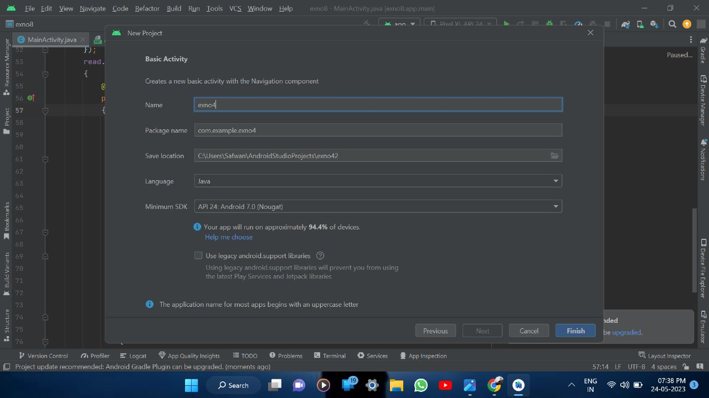



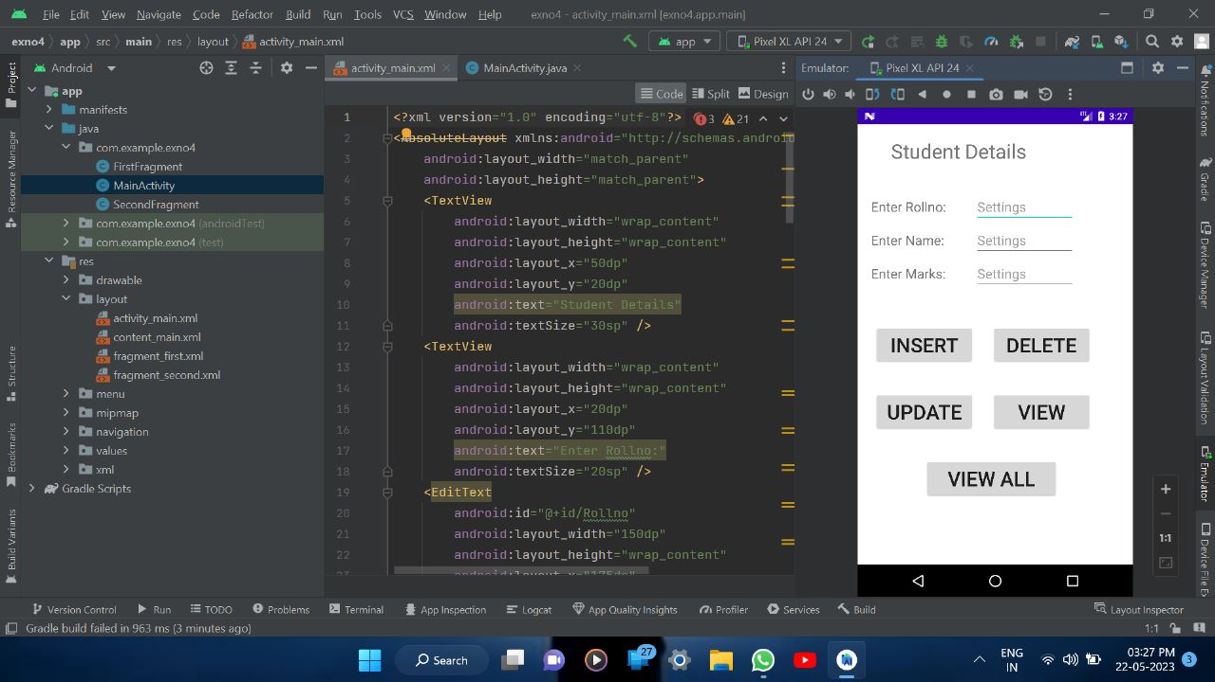

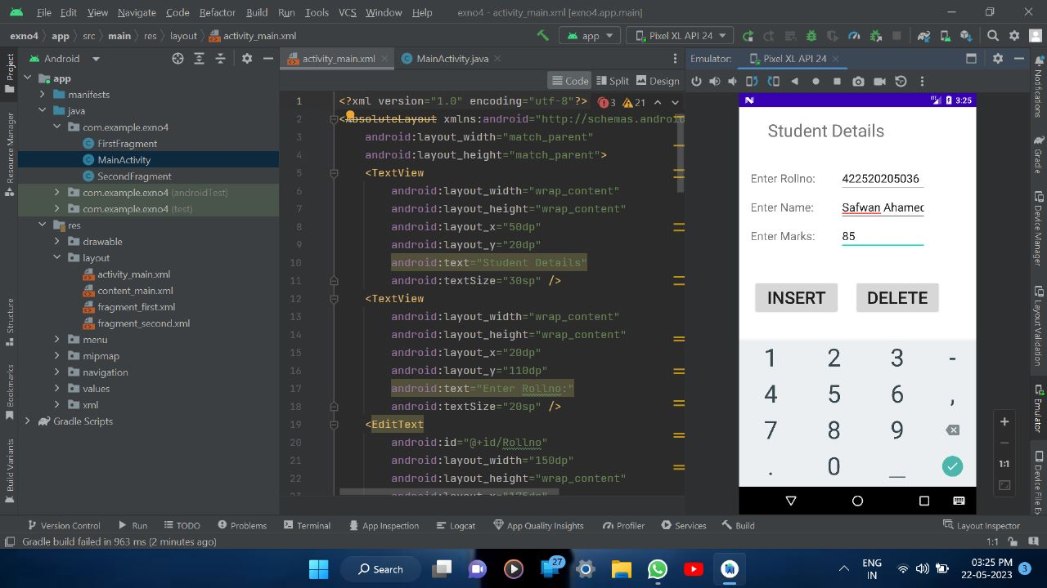

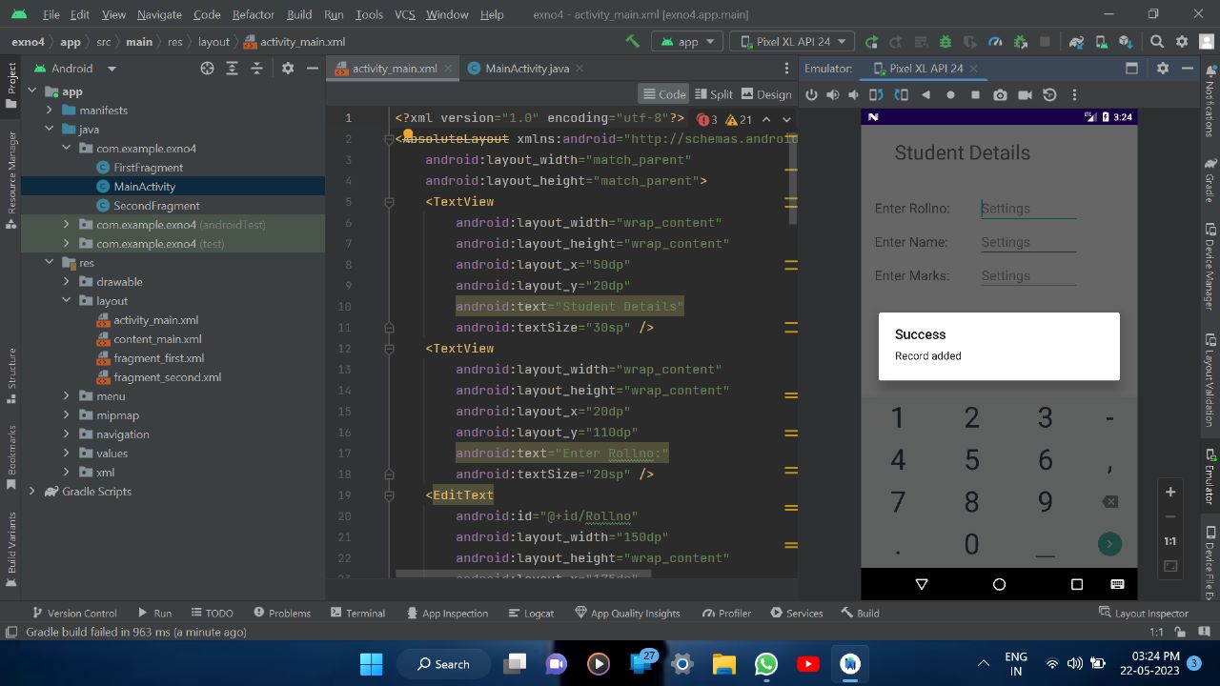

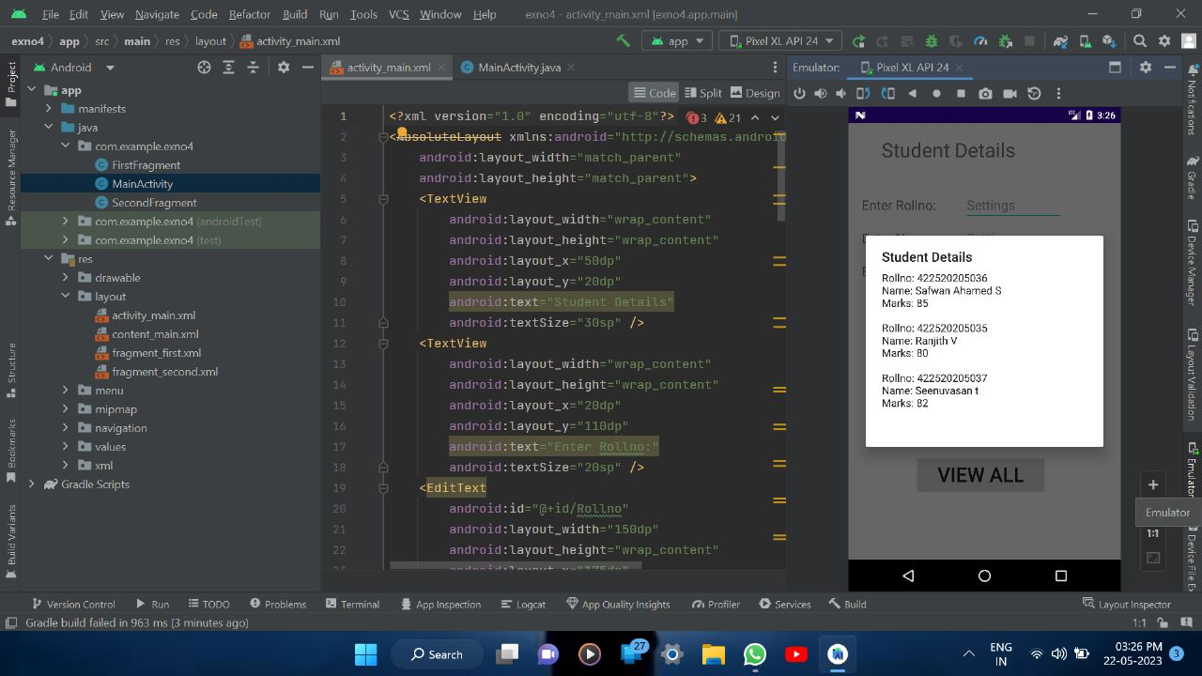

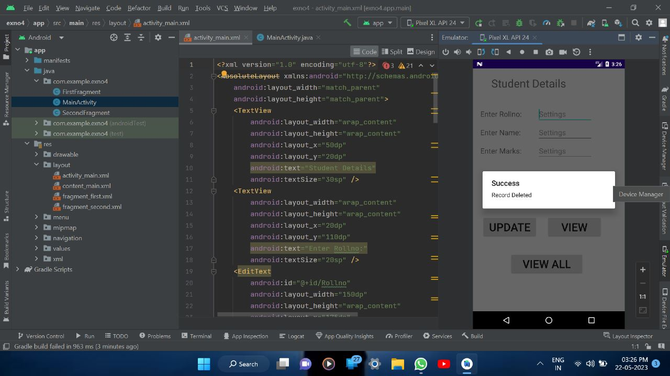

**RESULT**

Thus a simple Android Application that uses makes use of databases. is designed Implemented and executed sucessfully

**PROGRAM 5:**

**MainActivity.java**

package com.example.exno5;

import android.app.NotificationChannel;

import android.app.NotificationManager;

import android.app.PendingIntent;

import android.content.Context;

import android.content.Intent;

import android.net.Uri;

import androidx.annotation.RequiresApi;

import androidx.core.app.NotificationCompat;

import androidx.appcompat.app.AppCompatActivity;

import androidx.core.app.Person;

import androidx.core.graphics.drawable.IconCompat;

import android.os.Build;

import android.os.Bundle;

import android.view.View;

import android.widget.Button;

import android.widget.Toast;

import java.util.Date;

public class MainActivity extends AppCompatActivity implements

View.OnClickListener {

NotificationManager notificationManager;

NotificationCompat.Builder builder;

NotificationChannel channel;

CharSequence charSequence = "";

@RequiresApi(api = Build.VERSION_CODES.O)

@Override

protected void onCreate(Bundle savedInstanceState) {

super.onCreate(savedInstanceState);

setContentView(R.layout.activity_main);

Button btnSimpleNotification =

findViewById(R.id.btnSimpleNotification);

Button btnNotificationIcon = findViewById(R.id.btnNotificationIcon);

Button btnNotificationImage = findViewById(R.id.btnNotificationImage);

Button btnNotificationWithGroupConvo =

findViewById(R.id.btnNotificationWithGroupConvo);

Button btnNotificationSemantic =

findViewById(R.id.btnNotificationSemantic);

charSequence = btnNotificationIcon.getText();

btnSimpleNotification.setOnClickListener(this);

btnNotificationIcon.setOnClickListener(this);

btnNotificationImage.setOnClickListener(this);

btnNotificationWithGroupConvo.setOnClickListener(this);

btnNotificationSemantic.setOnClickListener(this);

notificationManager = (NotificationManager)

getSystemService(Context.NOTIFICATION_SERVICE);

CharSequence name = "My Notification";

String description = "welcome seenuvasan";

int importance = NotificationManager.IMPORTANCE_DEFAULT;

channel = new NotificationChannel("1", name, importance);

channel.setDescription(description);

builder = new NotificationCompat.Builder(MainActivity.this,

channel.getId())

.setSmallIcon(R.mipmap.ic_launcher);

notificationManager.createNotificationChannel(channel);

}

@Override

public void onClick(View v) {

switch (v.getId()) {

case R.id.btnSimpleNotification:

simpleNotification();

break;

case R.id.btnNotificationIcon:

notificationWithIcon();

break;

case R.id.btnNotificationImage:

notificationWithImage();

break;

case R.id.btnNotificationWithGroupConvo:

notificationWithGroupConvo();

break;

case R.id.btnNotificationSemantic:

notificationSemantic();

break;

}

}

private void simpleNotification() {

Person jd = new Person.Builder().setName("JournalDev

") .setImportant(true) .build();

new NotificationCompat.MessagingStyle(jd)

.addMessage("Check me out", new Date().getTime(),

jd) .setBuilder(builder);

notificationManager.notify(1, builder.build());

}

private void notificationWithIcon() {

Person anupam = new Person.Builder()

.setName("Anupam")

// .setIcon(IconCompat.createWithResource(this, R.drawable.index))

.setIcon(IconCompat.createWithResource(this, R.drawable.ic_launcher_foreground)).setImportant(true) .build();

new NotificationCompat.MessagingStyle(anupam)

.addMessage("Check out my latest article!", new Date().getTime(), anupam)

.setBuilder(builder);

notificationManager.notify(2, builder.build());

}

private void notificationWithImage() {

Person bot = new Person.Builder()

.setName("Bot") .setImportant(true)

.setBot(true) .build();

Uri uri = Uri.parse("android.resource://com.journaldev.androidpnotifications/drawable/"+R.drawable.ic_launcher_background);

NotificationCompat.MessagingStyle.Message messag = new

NotificationCompat.MessagingStyle.Message("Check out my latest article!", new Date().getTime(), bot);

message.setData("image/*",uri);

new NotificationCompat.MessagingStyle(bot)

.addMessage(message) .setGroupConversation(true).setBuilder(builder);

notificationManager.notify(3, builder.build());

}

private void notificationWithGroupConvo()

{

Person jd = new Person.Builder()

.setName("JournalDev") .build();

Person anupam = new Person.Builder()

.setName("Anupam")

.setIcon(IconCompat.createWithResource(this,

R.drawable.ic_launcher_foreground))

.setImportant(true).build();

Person bot = new Person.Builder()

.setName("Bot").setBot(true) .build();

Uri uri =

Uri.parse("android.resource://com.journaldev.androidpnotifications/

drawable/"+R.drawable.ic_launcher_background);

NotificationCompat.MessagingStyle.Message message =new

NotificationCompat.MessagingStyle.Message("", new Date().getTime(), bot);

message.setData("image/*",uri);

new NotificationCompat.MessagingStyle(bot)

.addMessage("Hi. How are you?", new Date().getTime(), anupam)

.addMessage(message)

.addMessage("Does this image look good?", new Date().getTime(), bot)

.addMessage("Looks good!", new Date().getTime(), jd)

.setGroupConversation(true).setConversationTitle("Sample Conversation")

.setBuilder(builder);

notificationManager.notify(4, builder.build());

}

private void notificationSemantic()

{

Person jd = new Person.Builder()

.setName("JournalDev")

.build();

Person anupam = new Person.Builder()

.setName("Anupam")

.setIcon(IconCompat.createWithResource(this, R.drawable.index))

.setImportant(true)

.build();

Person bot = new Person.Builder()

.setName("Bot")

.setBot(true)

.build();

Uri uri =

Uri.parse("android.resource://com.journaldev.androidpnotifications/

drawable/"+R.drawable.ic_launcher_background);

Intent intent = new Intent(this, MainActivity.class);

intent.putExtra("hi","Notifications were read");

PendingIntent pendingIntent = PendingIntent.getActivity(this, 0, intent, 0);

NotificationCompat.MessagingStyle.Message

message =new

NotificationCompat.MessagingStyle.Message("", new Date().getTime(), bot);

message.setData("image/*",uri);

NotificationCompat.Action replyAction =

new NotificationCompat.Action.Builder(

R.drawable.ic_launcher_background, "MARK READ",

pendingIntent)

.setSemanticAction(NotificationCompat.Action.SEMANTIC_A

CTION_MARK_AS_READ)

.build();

NotificationCompat.Builder separateBuilder = builder;

separateBuilder.addAction(replyAction);

new NotificationCompat.MessagingStyle(bot)

.addMessage("Hi. How are you?", new Date().getTime(), anupam)

.addMessage(message)

.addMessage("Does this image look good?", new Date().getTime(), bot)

.addMessage("Looks good!", new Date().getTime(), jd)

.setGroupConversation(true)

.setConversationTitle("Sample Conversation")

.setBuilder(separateBuilder);

notificationManager.notify(5, separateBuilder.build());

}

@Override

protected void onResume() {

super.onResume();

if(getIntent()!=null && getIntent().getExtras()!=null)

{

String value = getIntent().getStringExtra("hi");

Toast.makeText(getApplicationContext(),value,Toast.LENGTH_LONG).show();

}

}

}

**activity_main.xml**

<?xml version="1.0" encoding="utf-8"?>

<LinearLayout xmlns:android="http://schemas.android.com/apk/res/android"

xmlns:app="http://schemas.android.com/apk/res-auto"

xmlns:tools="http://schemas.android.com/tools"

android:layout_width="match_parent"

android:layout_height="match_parent"

android:orientation="vertical"

android:gravity="center"

tools:context=".MainActivity">

<Button

android:id="@+id/btnSimpleNotification"

android:layout_width="wrap_content"

android:layout_height="wrap_content"

android:text="Simple Notification" />

<Button

android:id="@+id/btnNotificationIcon"

android:layout_width="wrap_content"

android:layout_height="wrap_content"

android:text="Notification With Icon" />

<Button

android:id="@+id/btnNotificationImage"

android:layout_width="wrap_content"

android:layout_height="wrap_content"

android:text="Notification With Image" />

<Button

android:id="@+id/btnNotificationWithGroupConvo"

android:layout_width="wrap_content"

android:layout_height="wrap_content"

android:text="Notification With Group Conversation" />

<Button

android:id="@+id/btnNotificationSemantic"

android:layout_width="wrap_content"

android:layout_height="wrap_content"

android:text="Exit" />

</LinearLayout>

**OUTPUT**

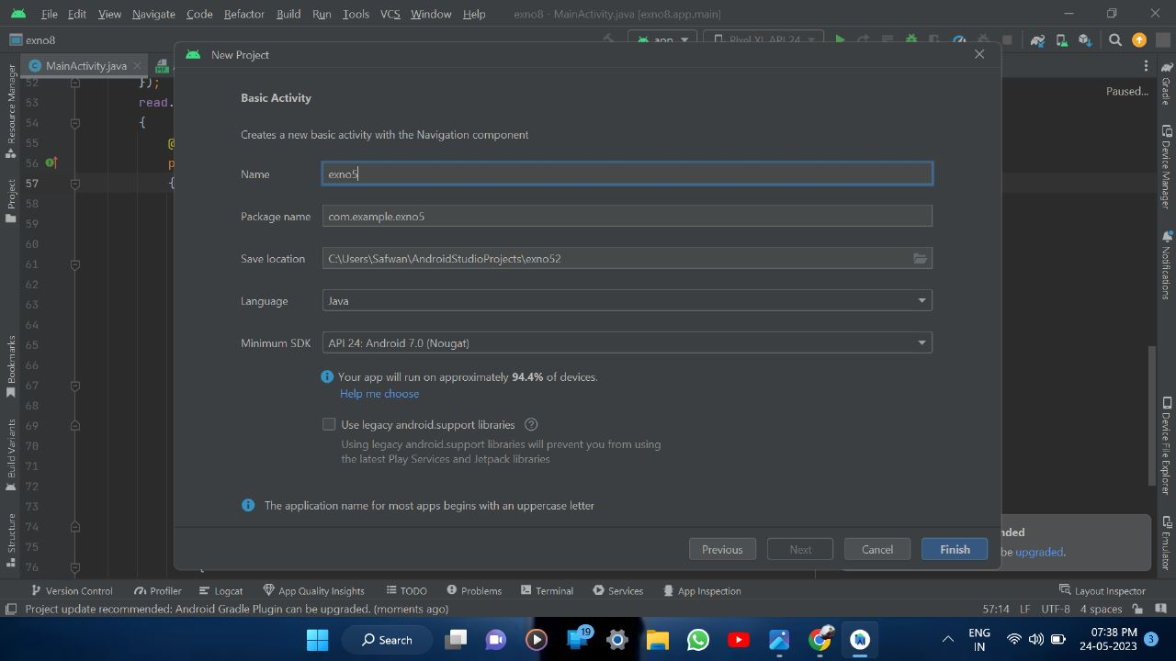



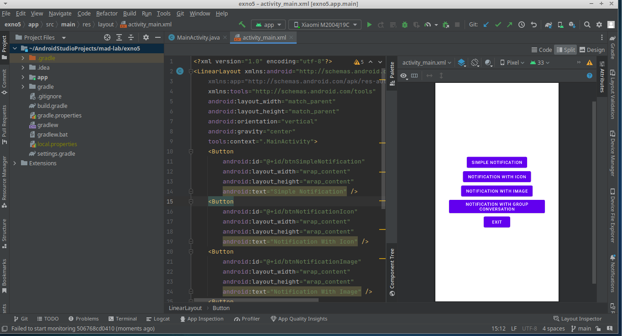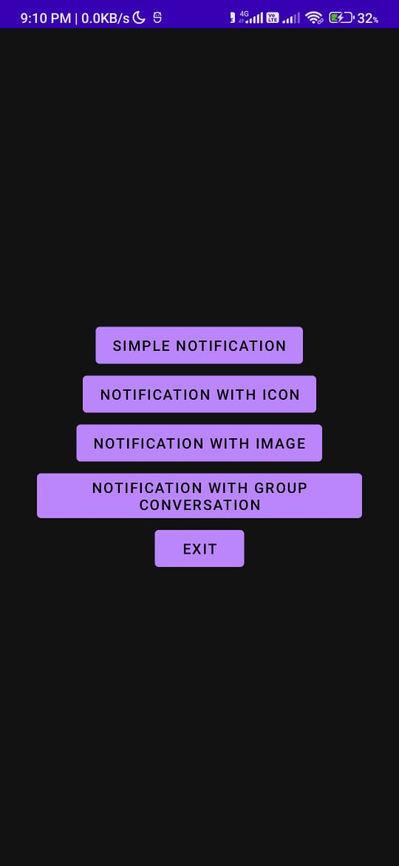

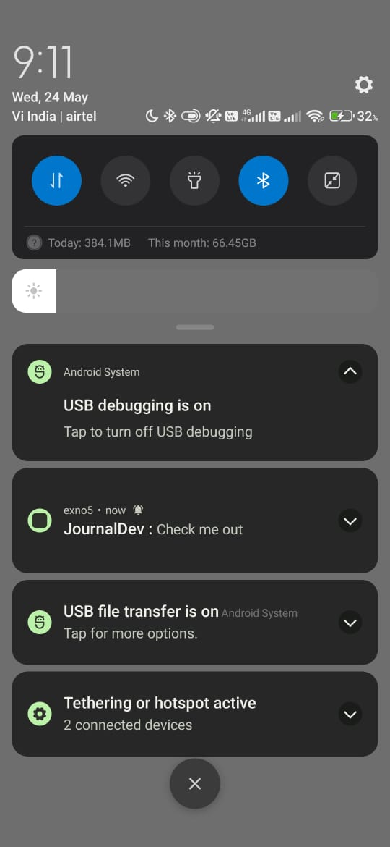

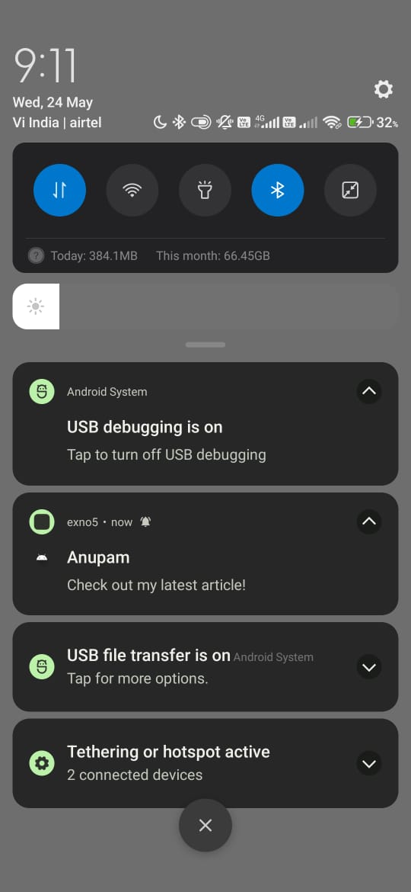

**RESULT**

Thus a simple Android Application that uses makes makes use of Notification Manager is designed Implemented and executed sucessfully

**PROGRAM 6:**

**MainActivity.java**

package com.example.exno6;

import android.os.Bundle;

//import android.support.v7.app.AppCompatActivity;

import android.view.View;

import android.widget.Button;

import android.widget.ImageView;

import androidx.appcompat.app.AppCompatActivity;

public class MainActivity extends AppCompatActivity

{

ImageView img;

Button bt1,bt2;

@Override

protected void onCreate(Bundle savedInstanceState)

{

super.onCreate(savedInstanceState);

setContentView(R.layout.activity_main);

bt1 = (Button)findViewById(R.id.button);

bt2= (Button) findViewById(R.id.button2);

img = (ImageView)findViewById(R.id.imageView);

bt1.setOnClickListener(new View.OnClickListener()

{

@Override

public void onClick(View v)

{

new Thread(new Runnable()

{

@Override

public void run()

{

img.post(new Runnable()

{

@Override

public void run()

{

img.setImageResource(R.drawable.india1);

}

});

}

}).start();

}

});

bt2.setOnClickListener(new View.OnClickListener()

{

@Override

public void onClick(View v)

{

new Thread(new Runnable()

{

@Override

public void run()

{

img.post(new Runnable()

{

@Override

public void run()

{

img.setImageResource(R.drawable.india2);

}

});

}

}).start();

}

});

}

}

**activity_main.xml**

<?xml version="1.0" encoding="utf-8"?>

<LinearLayout xmlns:android="http://schemas.android.com/apk/res/android"

android:layout_width="match_parent"

android:layout_height="match_parent"

android:orientation="vertical" >

<ImageView

android:id="@+id/imageView"

android:layout_width="250dp"

android:layout_height="250dp"

android:layout_margin="50dp"

android:layout_gravity="center" />

<Button

android:id="@+id/button"

android:layout_width="wrap_content"

android:layout_height="wrap_content"

android:layout_margin="10dp"

android:layout_gravity="center"

android:text="Load Image 1" />

<Button

android:id="@+id/button2"

android:layout_width="wrap_content"

android:layout_height="wrap_content"

android:layout_margin="10dp"

android:layout_gravity="center"

android:text="Load image 2" />

</LinearLayout>

**OUTPUT**

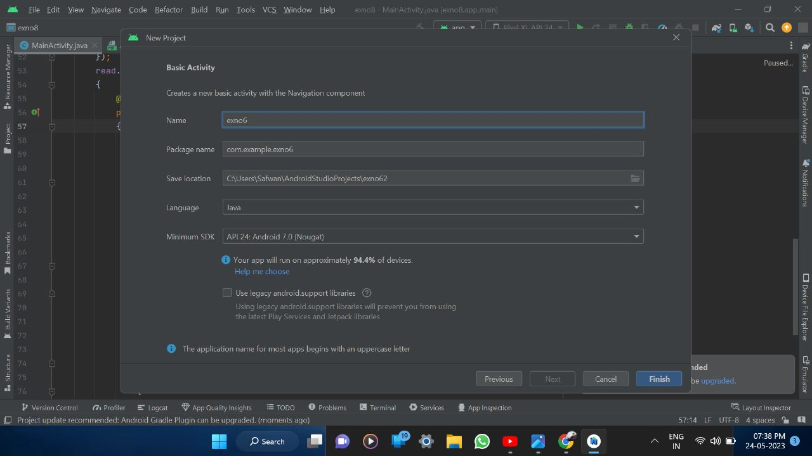



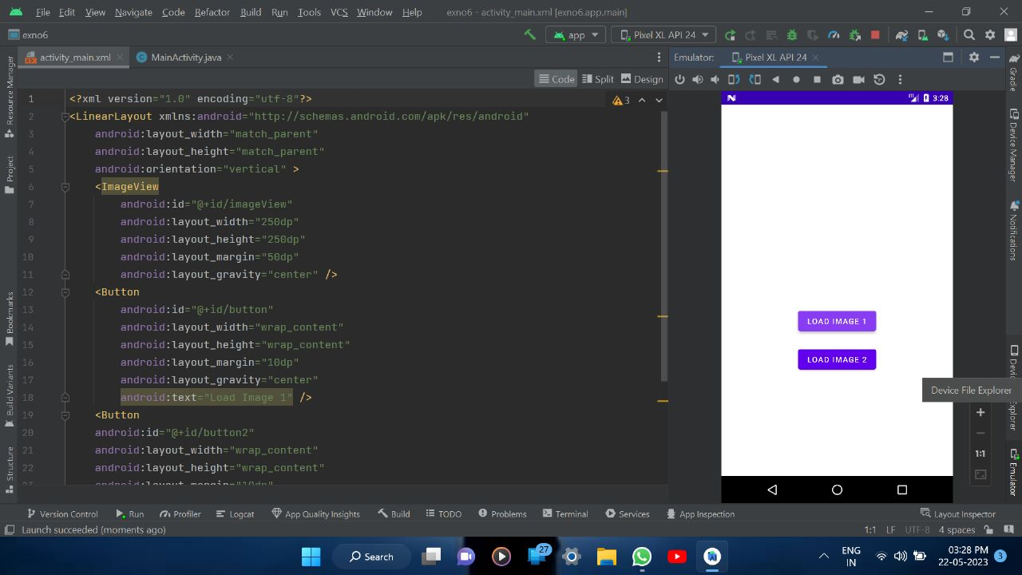

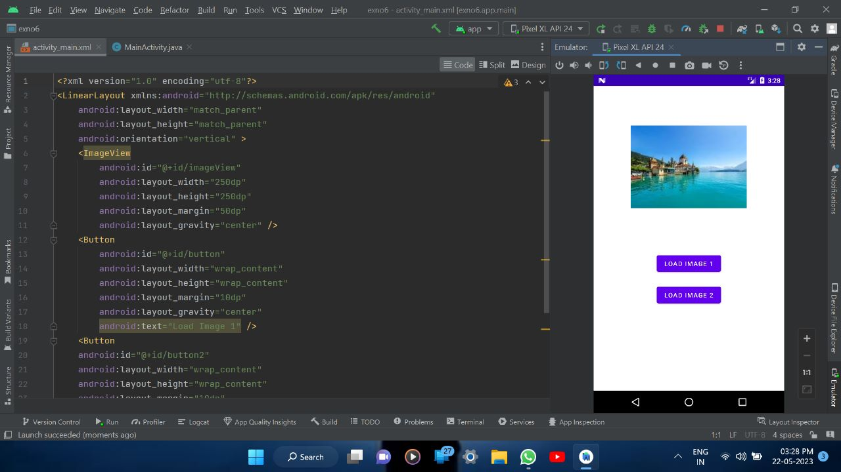

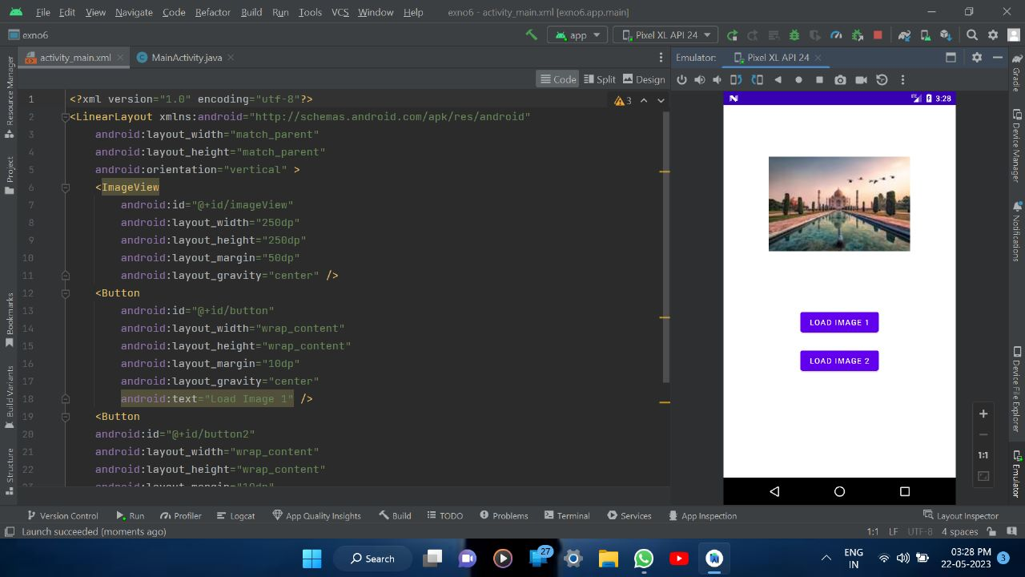

**RESULT**

Thus a simple Android Application that uses makes makes use of uses Multi-threading is designed Implemented and executed sucessfully

**PROGRAM 7:**

**MainActivity.java**

package com.example.exno7;

import android.Manifest;

import android.annotation.SuppressLint;

import android.content.Context;

import android.content.Intent;

import android.content.pm.PackageManager;

import android.location.Location;

import android.location.LocationManager;

import android.os.Bundle;

import android.os.Looper;

import android.provider.Settings;

import android.widget.TextView;

import android.widget.Toast;

import androidx.annotation.NonNull;

import androidx.appcompat.app.AppCompatActivity;

import androidx.core.app.ActivityCompat;

import com.google.android.gms.location.FusedLocationProviderClient;

import com.google.android.gms.location.LocationCallback;

import com.google.android.gms.location.LocationRequest;

import com.google.android.gms.location.LocationResult;

import com.google.android.gms.location.LocationServices;

import com.google.android.gms.tasks.OnCompleteListener;

import com.google.android.gms.tasks.Task;

public class MainActivity extends AppCompatActivity {

FusedLocationProviderClient mFusedLocationClient;

TextView latitudeTextView, longitTextView;

int PERMISSION_ID = 44;

@Override

protected void onCreate(Bundle savedInstanceState) {

super.onCreate(savedInstanceState);

setContentView(R.layout.activity_main);

latitudeTextView = findViewById(R.id.latTextView);

longitTextView = findViewById(R.id.lonTextView);

mFusedLocationClient =

LocationServices.getFusedLocationProviderClient(this);

// method to get the location

getLastLocation();

}

@SuppressLint("MissingPermission")

private void getLastLocation() {

// check if permissions are given

if (checkPermissions()) {

// check if location is enabled

if (isLocationEnabled()) {

// getting last

// location from

// FusedLocationClient

// object

mFusedLocationClient.getLastLocation().addOnCompleteListener(new

OnCompleteListener<Location>() {

@Override

public void onComplete(@NonNull Task<Location> task) {

Location location = task.getResult();

if (location == null) {

requestNewLocationData();

} else {

latitudeTextView.setText(location.getLatitude() + "");

longitTextView.setText(location.getLongitude() + "");

}

}

});

} else {

Toast.makeText(this, "Please turn on" + " your location...",

Toast.LENGTH_LONG).show();

Intent intent = new

Intent(Settings.ACTION_LOCATION_SOURCE_SETTINGS);

startActivity(intent);

}

} else {

// if permissions aren't available,

// request for permissions

requestPermissions();

}

}

@SuppressLint("MissingPermission")

private void requestNewLocationData() {

// Initializing LocationRequest

// object with appropriate methods

LocationRequest mLocationRequest = new LocationRequest();

mLocationRequest.setPriority(LocationRequest.PRIORITY_HIGH_ACCURA

CY);

mLocationRequest.setInterval(5);

mLocationRequest.setFastestInterval(0);

mLocationRequest.setNumUpdates(1);

// setting LocationRequest

// on FusedLocationClient

mFusedLocationClient =

LocationServices.getFusedLocationProviderClient(this);

mFusedLocationClient.requestLocationUpdates(mLocationRequest,

mLocationCallback, Looper.myLooper());

}

private LocationCallback mLocationCallback = new LocationCallback() {

@Override

public void onLocationResult(LocationResult locationResult) {

Location mLastLocation = locationResult.getLastLocation();

latitudeTextView.setText("Latitude: " + mLastLocation.getLatitude() + "");

longitTextView.setText("Longitude: " + mLastLocation.getLongitude() + "");

}

};

// method to check for permissions

private boolean checkPermissions() {

return ActivityCompat.checkSelfPermission(this,

Manifest.permission.ACCESS_COARSE_LOCATION) ==

PackageManager.PERMISSION_GRANTED &&

ActivityCompat.checkSelfPermission(this,

Manifest.permission.ACCESS_FINE_LOCATION) ==

PackageManager.PERMISSION_GRANTED;

// If we want background location

// on Android 10.0 and higher,

// use:

// ActivityCompat.checkSelfPermission(this,

Manifest.permission.ACCESS_BACKGROUND_LOCATION) ==

PackageManager.PERMISSION_GRANTED

}

// method to request for permissions

private void requestPermissions() {

ActivityCompat.requestPermissions(this, new String[]{

Manifest.permission.ACCESS_COARSE_LOCATION,

Manifest.permission.ACCESS_FINE_LOCATION},

PERMISSION_ID);

}

// method to check

// if location is enabled

private boolean isLocationEnabled() {

LocationManager locationManager = (LocationManager)

getSystemService(Context.LOCATION_SERVICE);

return

locationManager.isProviderEnabled(LocationManager.GPS_PROVIDER) ||

locationManager.isProviderEnabled(LocationManager.NETWORK_PROVIDE

R);

}

// If everything is alright then

@Override

public void

onRequestPermissionsResult(int requestCode, @NonNull String[]

permissions, @NonNull int[] grantResults) {

super.onRequestPermissionsResult(requestCode, permissions,

grantResults);

if (requestCode == PERMISSION_ID) {

if (grantResults.length > 0 && grantResults[0] ==

PackageManager.PERMISSION_GRANTED) {

getLastLocation();

}

}

}

@Override

public void onResume() {

super.onResume();

if (checkPermissions()) {

getLastLocation();

}

}

}

**activity_main.xml**

<?xml version="1.0" encoding="utf-8"?>

<LinearLayout

xmlns:android="http://schemas.android.com/apk/res/android"

android:layout_width="match_parent"

android:layout_height="match_parent"

android:background="@color/teal_700"

android:gravity="center"

android:orientation="vertical">

<TextView

android:layout_width="wrap_content"

android:layout_height="wrap_content"

android:fontFamily="sans-serif-black"

android:text="Latitude:" />

<TextView

android:id="@+id/latTextView"

android:layout_width="wrap_content"

android:layout_height="wrap_content"

android:text="Latitude will be here! "

android:textColor="#f5f5f5" />

<TextView

android:layout_width="wrap_content"

android:layout_height="wrap_content"

android:fontFamily="sans-serif-black"

android:text="Longitude:" />

<TextView

android:id="@+id/lonTextView"

android:layout_width="wrap_content"

android:layout_height="wrap_content"

android:text="Longitude will be here! "

android:textColor="#f5f5f5" />

</LinearLayout>

**AndroidManifest.xml**

<?xml version="1.0" encoding="utf-8"?>

<manifest xmlns:android="http://schemas.android.com/apk/res/android"

xmlns:tools="http://schemas.android.com/tools">

<uses-permission android:name="android.permission.ACCESS_COARSE_LOCATION" />

<uses-permission android:name="android.permission.ACCESS_FINE_LOCATION" />

<uses-permission android:name = "android.permission.INTERNET" />

<uses-permission android:name="android.permission.ACCESS_COARSE_LOCATION" />

<uses-permission android:name="android.permission.ACCESS_FINE_LOCATION" />

<uses-permission android:name="android.permission.ACCESS_BACKGROUND_LOCATION" />

<application

android:allowBackup="true"

android:dataExtractionRules="@xml/data_extraction_rules"

android:fullBackupContent="@xml/backup_rules"

android:icon="@mipmap/ic_launcher"

android:label="@string/app_name"

android:roundIcon="@mipmap/ic_launcher_round"

android:supportsRtl="true"

android:theme="@style/Theme.Exno7"

tools:targetApi="31">

<activity

android:name=".MainActivity"

android:exported="true"

android:label="@string/app_name"

android:theme="@style/Theme.Exno7.NoActionBar">

<intent-filter>

<action android:name="android.intent.action.MAIN" />

<category android:name="android.intent.category.LAUNCHER" />

</intent-filter>

<meta-data

android:name="android.app.lib_name"

android:value="" />

</activity> </application></manifest>

**OUTPUT**

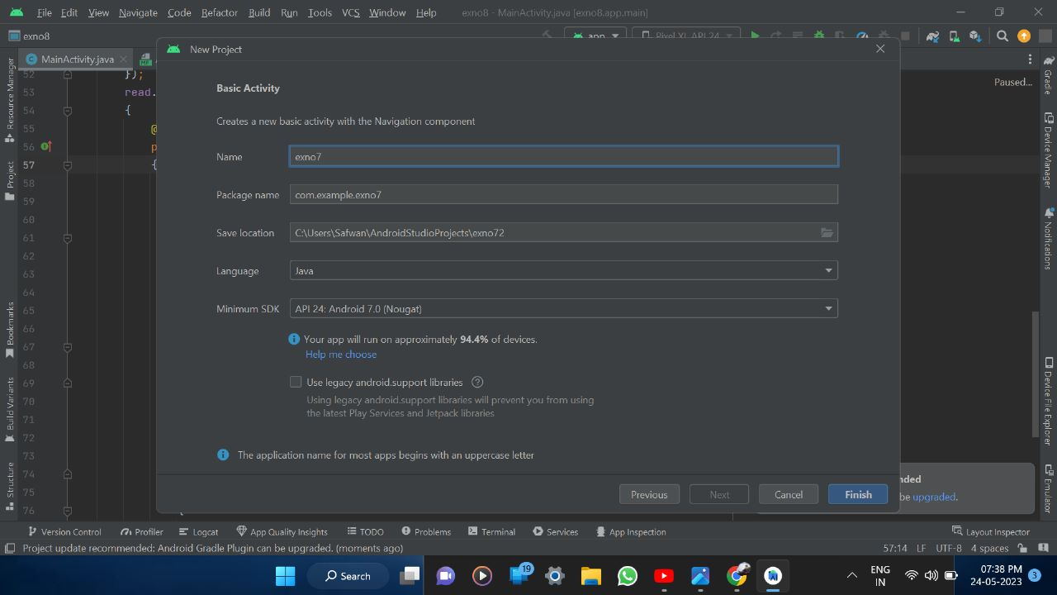



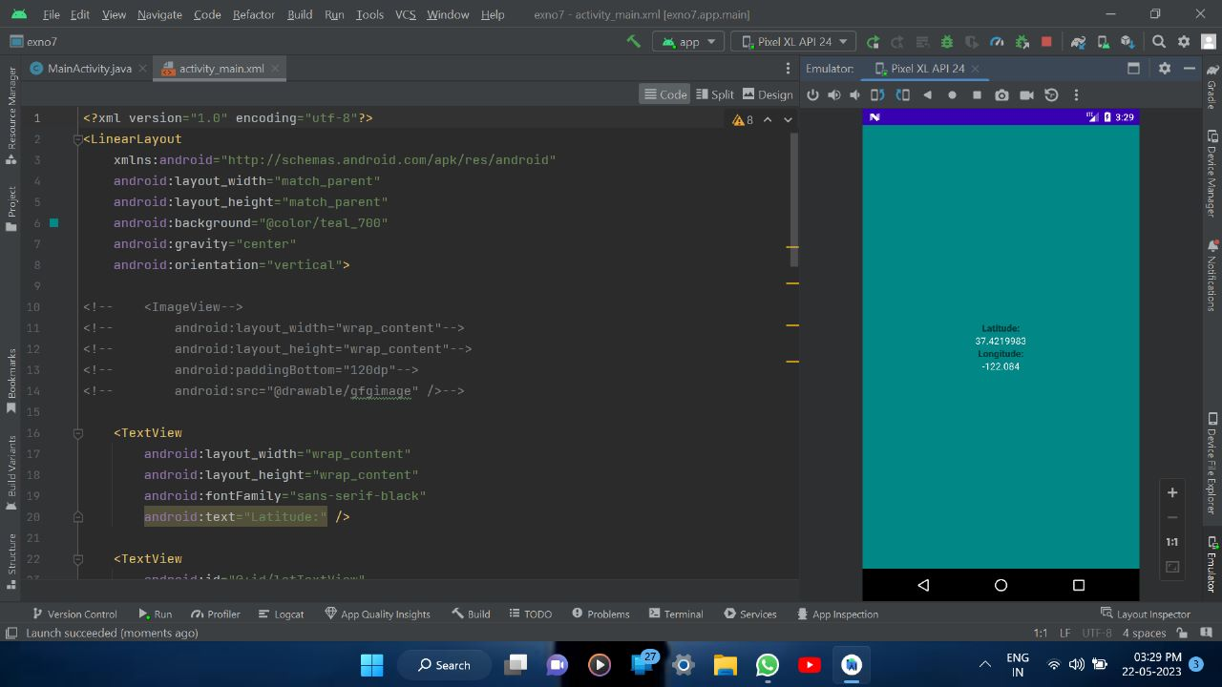

**RESULT**

Thus a simple Android native application that uses GPS location information is designed Implemented and executed sucessfully

**PROGRAM 8:**

**MainActivity.java**

package com.example.exno8;

import android.os.Bundle;

//import android.support.v7.app.AppCompatActivity;

import android.view.View;

import android.widget.Button;

import android.widget.EditText;

import android.widget.Toast;

import java.io.BufferedReader;

import java.io.File;

import java.io.FileInputStream;

import java.io.FileOutputStream;

import java.io.InputStreamReader;

import androidx.appcompat.app.AppCompatActivity;

public class MainActivity extends AppCompatActivity

{

EditText e1;

Button write,read,clear;

@Override

protected void onCreate(Bundle savedInstanceState)

{

super.onCreate(savedInstanceState);

setContentView(R.layout.activity_main);

e1= (EditText) findViewById(R.id.editText);

write= (Button) findViewById(R.id.button);

read= (Button) findViewById(R.id.button2);

clear= (Button) findViewById(R.id.button3);

write.setOnClickListener(new View.OnClickListener()

{

@Override

public void onClick(View v)

{

String message=e1.getText().toString();

try

{

File file = getFilesDir();

System.out.println("seenuvasan phone file path"+file.toString());

File f=new File( file+"/myfile.txt");

f.createNewFile();

FileOutputStream fout=new FileOutputStream(f);

fout.write(message.getBytes());

fout.close();

Toast.makeText(getBaseContext(),"Data Written in storage",Toast.LENGTH_LONG).show();

}

catch (Exception e)

{

Toast.makeText(getBaseContext(),e.getMessage(),Toast.LENGTH_LONG).show();

}

}

});

read.setOnClickListener(new View.OnClickListener()

{

@Override

public void onClick(View v)

{

String message;

String buf = "";

try

{

File file = getFilesDir();

File f = new File(file+"/myfile.txt");

FileInputStream fin = new FileInputStream(f);

BufferedReader br = new BufferedReader(new InputStreamReader(fin));

while ((message = br.readLine()) != null)

{

buf += message;

}

e1.setText(buf);

br.close();

fin.close();

Toast.makeText(getBaseContext(),"Data Recived from Storage",Toast.LENGTH_LONG).show();

}

catch (Exception e)

{

Toast.makeText(getBaseContext(), e.getMessage(), Toast.LENGTH_LONG).show();

}

}

});

clear.setOnClickListener(new View.OnClickListener()

{

@Override

public void onClick(View v)

{

e1.setText("");

}

});

}

}

**activity_main.xml**

<?xml version="1.0" encoding="utf-8"?>

<LinearLayout xmlns:android="http://schemas.android.com/apk/res/android"

android:layout_width="match_parent"

android:layout_height="match_parent"

android:layout_margin="20dp"

android:orientation="vertical">

<EditText

android:id="@+id/editText"

android:layout_width="match_parent"

android:layout_height="wrap_content"

android:singleLine="true"

android:textSize="30dp" />

<Button

android:id="@+id/button"

android:layout_width="match_parent"

android:layout_height="wrap_content"

android:layout_margin="10dp"

android:text="Write Data"

android:textSize="30dp" />

<Button

android:id="@+id/button2"

android:layout_width="match_parent"

android:layout_height="wrap_content"

android:layout_margin="10dp"

android:text="Read data"

android:textSize="30dp" />

<Button

android:id="@+id/button3"

android:layout_width="match_parent"

android:layout_height="wrap_content"

android:layout_margin="10dp"

android:text="Clear"

android:textSize="30dp" />

</LinearLayout>

**OUTPUT**

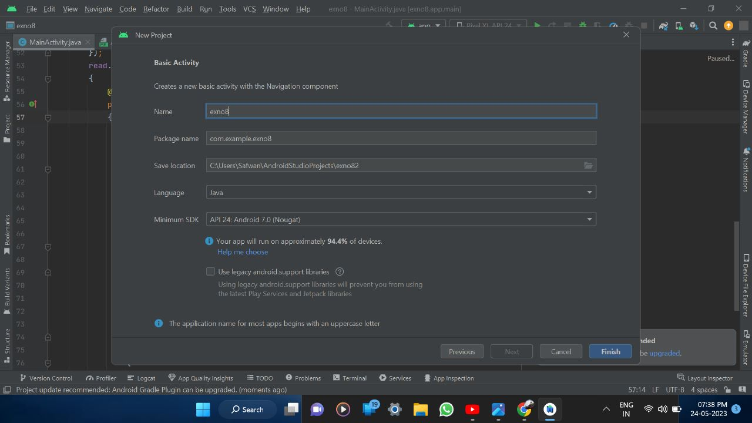



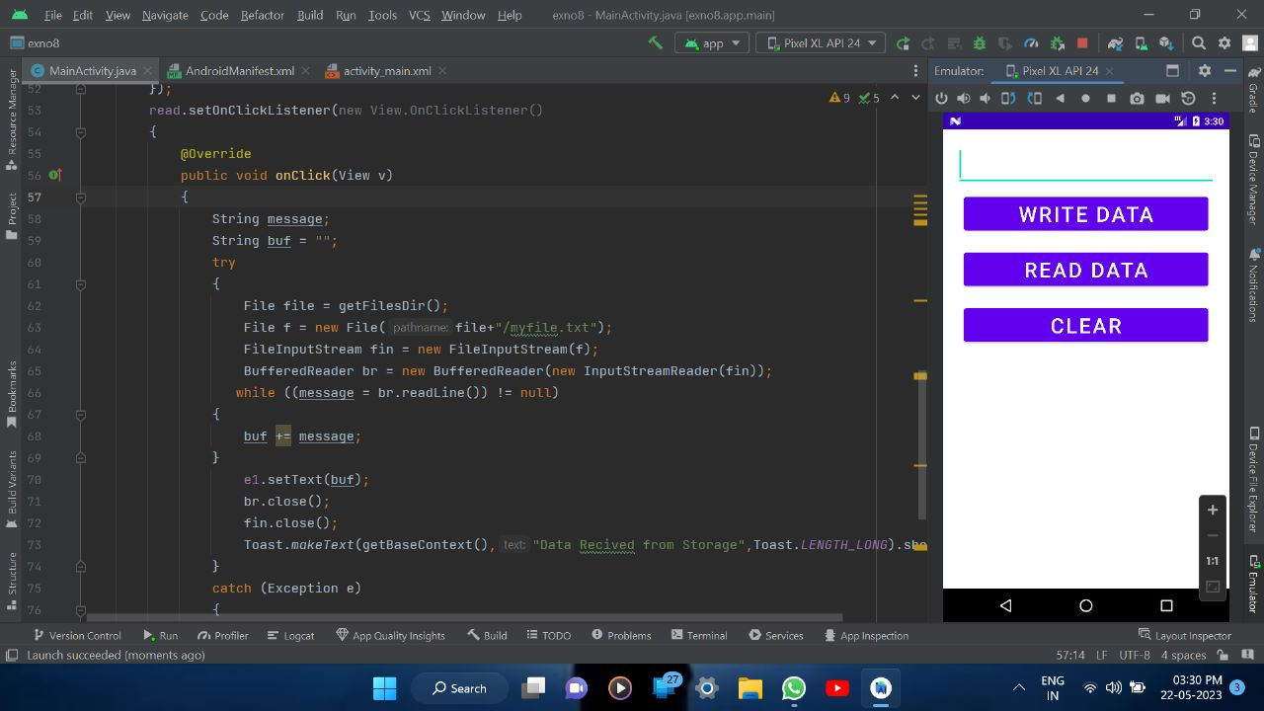

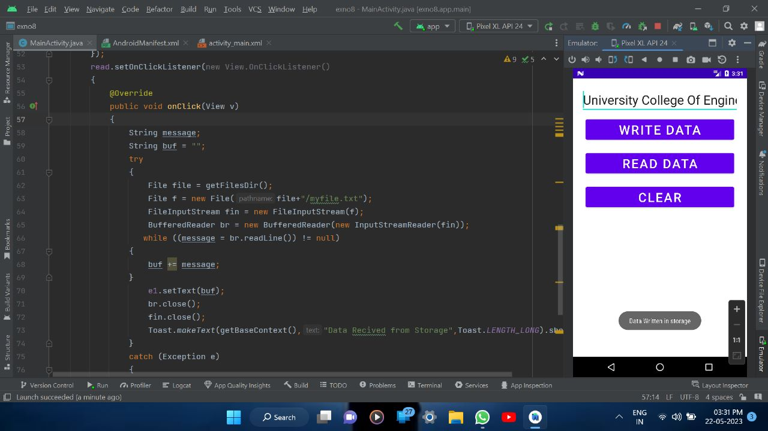

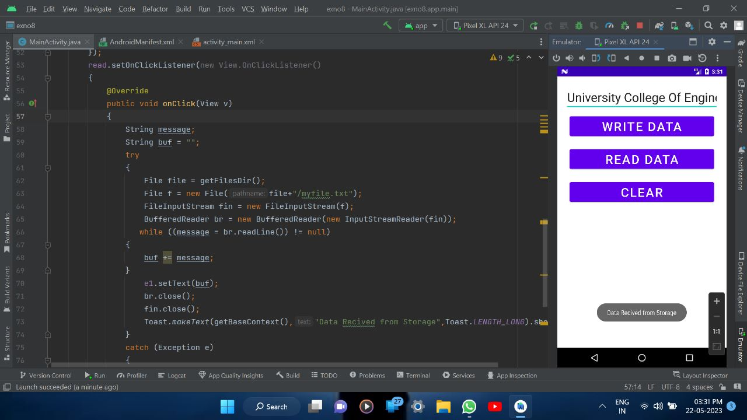

**RESULT**

Thus a simple Android Application that writes data to the SD card is designed Implemented and executed sucessfully

**PROGRAM 9:**

**MainActivity.java**

package com.example.exno9;

import android.app.NotificationChannel;

import android.app.NotificationManager;

import android.content.Context;

import androidx.annotation.RequiresApi;

import androidx.core.app.NotificationCompat;

import androidx.appcompat.app.AppCompatActivity;

import androidx.core.app.Person;

import android.os.Build;

import android.os.Bundle;

import android.view.View;

import android.widget.Button;

import java.util.Date;

import android.widget.EditText;

public class MainActivity extends AppCompatActivity implements View.OnClickListener {

NotificationManager notificationManager;

NotificationCompat.Builder builder;

NotificationChannel channel;

CharSequence charSequence = "";

EditText e;

@RequiresApi(api = Build.VERSION_CODES.O)

@Override

protected void onCreate(Bundle savedInstanceState) {

super.onCreate(savedInstanceState);

setContentView(R.layout.activity_main);

Button btnSimpleNotification = findViewById(R.id.Button);

e= (EditText) findViewById(R.id.editText);

String msg = e.toString();

btnSimpleNotification.setOnClickListener(this);

notificationManager = (NotificationManager) getSystemService(Context.NOTIFICATION_SERVICE);

CharSequence name = "My Notification";

String description = "welcome seenuvasan";

int importance = NotificationManager.IMPORTANCE_DEFAULT;

channel = new NotificationChannel("1", name, importance);

channel.setDescription(description);

builder = new NotificationCompat.Builder(MainActivity.this, channel.getId())

.setSmallIcon(R.mipmap.ic_launcher);

notificationManager.createNotificationChannel(channel);

}

@Override

public void onClick(View v) {

switch (v.getId()) {

case R.id.Button:

simpleNotification();

break;

}

}

private void simpleNotification() {

Person jd = new Person.Builder().setName("allert") .setImportant(true) .build();

new NotificationCompat.MessagingStyle(jd)

.addMessage(e.getText(), new Date().getTime(), jd) .setBuilder(builder);

notificationManager.notify(1, builder.build());

}

}

**activity_main.xml**

<?xml version="1.0" encoding="utf-8"?>

<LinearLayout xmlns:android="http://schemas.android.com/apk/res/android"

android:layout_width="match_parent"

android:layout_height="match_parent"

android:layout_margin="10dp"

android:orientation="vertical">

<TextView

android:layout_width="wrap_content"

android:layout_height="wrap_content"

android:text="Message Form Ucev"

android:textSize="30sp" />

<EditText

android:id="@+id/editText"

android:layout_width="match_parent"

android:layout_height="wrap_content"

android:textSize="30sp" />

<Button

android:id="@+id/Button"

android:layout_width="wrap_content"

android:layout_height="wrap_content"

android:layout_margin="30dp"

android:layout_gravity="center"

android:text="Notify"

android:textSize="30sp"/> </LinearLayout>

**OUTPUT**

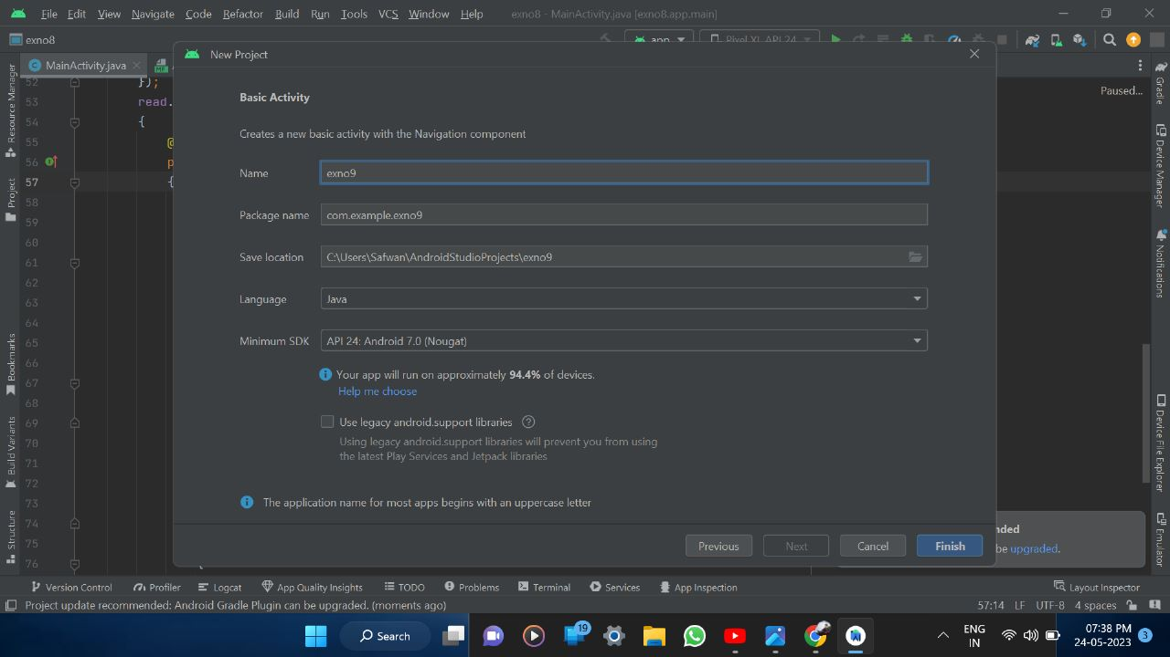



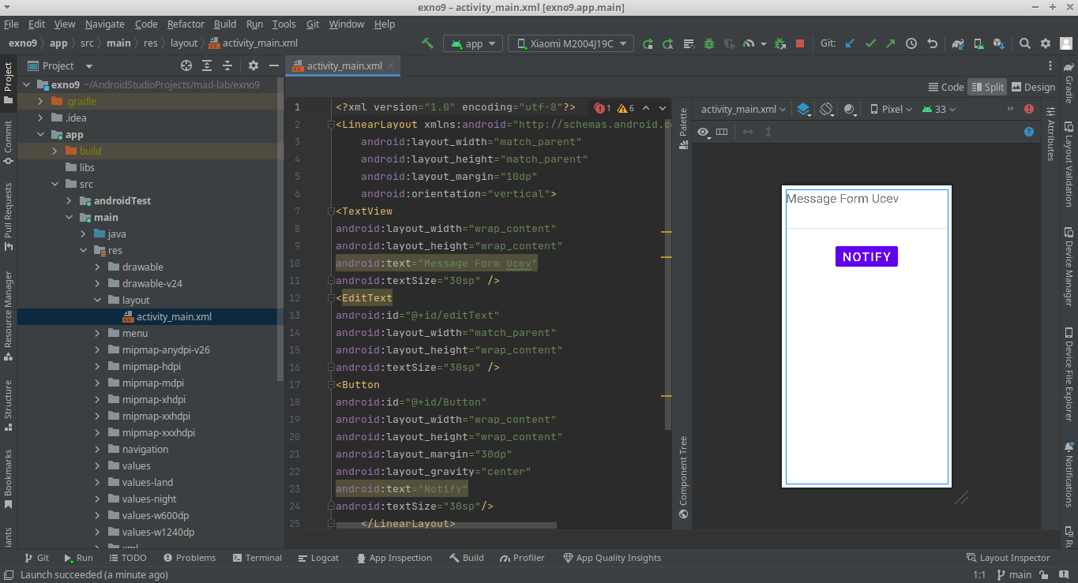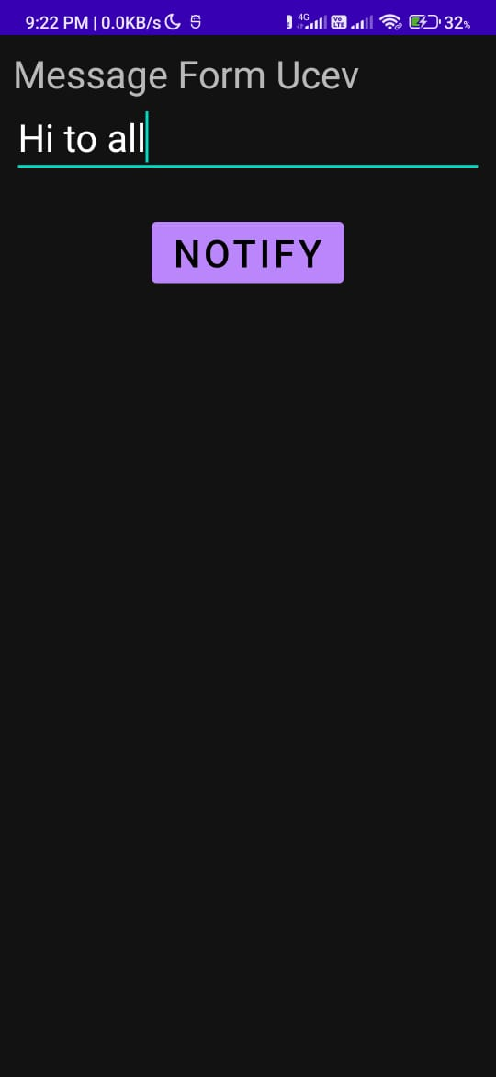

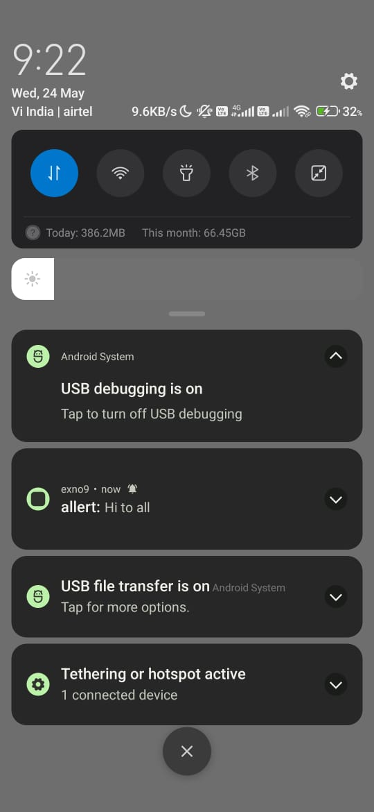

**RESULT**

Thus a simple Android Application that creates an alert upon receiving a message is designed Implemented and executed sucessfully

**PROGRAM 10:**

**MainActivity.java**

package com.example.exno10;

import android.app.ListActivity;

import android.content.Intent;

import android.net.Uri;

import android.os.AsyncTask;

import android.os.AsyncTask;

import android.os.Bundle;

import android.view.View;

import android.widget.ArrayAdapter;

import android.widget.ListView;

import org.xmlpull.v1.XmlPullParser;

import org.xmlpull.v1.XmlPullParserException;

import org.xmlpull.v1.XmlPullParserFactory;

import java.io.IOException;

import java.io.InputStream;

import java.net.MalformedURLException;

import java.net.URL;

import java.util.ArrayList;

import java.util.List;

public class MainActivity extends ListActivity

{

List headlines;

List links;

@Override

protected void onCreate(Bundle savedInstanceState)

{

super.onCreate(savedInstanceState);

new MyAsyncTask().execute();

}

class MyAsyncTask extends AsyncTask<Object,Void,ArrayAdapter>

{

@Override

protected ArrayAdapter doInBackground(Object[] params)

{

headlines = new ArrayList();

links = new ArrayList();

try

{

URL url = new URL("https://codingconnect.net/feed");

XmlPullParserFactory factory = XmlPullParserFactory.newInstance();

factory.setNamespaceAware(false);

XmlPullParser xpp = factory.newPullParser();

// We will get the XML from an input stream

xpp.setInput(getInputStream(url), "UTF_8");

boolean insideItem = false;

// Returns the type of current event: START_TAG, END_TAG, etc..

int eventType = xpp.getEventType();

while (eventType != XmlPullParser.END_DOCUMENT)

{

if (eventType == XmlPullParser.START_TAG)

{

if (xpp.getName().equalsIgnoreCase("item"))

{

insideItem = true;

}

else if (xpp.getName().equalsIgnoreCase("title"))

{

if (insideItem)

headlines.add(xpp.nextText()); //extract the headline

}

else if (xpp.getName().equalsIgnoreCase("link"))

{

if (insideItem)

links.add(xpp.nextText()); //extract the link of article

}

}

else

if(eventType==XmlPullParser.END_TAG&&xpp.getName().equalsIgnoreCase

("item"))

{

insideItem=false;

}

eventType = xpp.next(); //move to next element

}

}

catch (MalformedURLException e)

{

e.printStackTrace();

}

catch (XmlPullParserException e)

{

e.printStackTrace();

}

catch (IOException e)

{

e.printStackTrace();

}

return null;

}

protected void onPostExecute(ArrayAdapter adapter)

{

adapter = new ArrayAdapter(MainActivity.this,

android.R.layout.simple_list_item_1,

headlines);

setListAdapter(adapter);

}

}

@Override

protected void onListItemClick(ListView l, View v, int position, long id)

{

Uri uri = Uri.parse((links.get(position)).toString());

Intent intent = new Intent(Intent.ACTION_VIEW, uri);

startActivity(intent);

}

public InputStream getInputStream(URL url)

{

try

{

return url.openConnection().getInputStream();

}

catch (IOException e)

{

return null;

} }}

**activity_main.xml**

<?xml version="1.0" encoding="utf-8"?>

<LinearLayout xmlns:android="http://schemas.android.com/apk/res/android"

android:layout_width="fill_parent"

android:layout_height="fill_parent"

android:orientation="vertical" >

<ListView

android:id="@+id/listView"

android:layout_width="match_parent"

android:layout_height="wrap_content" />

</LinearLayout>

**AndroidManifest.xml**

<?xml version="1.0" encoding="utf-8"?>

<manifest xmlns:android="http://schemas.android.com/apk/res/android"

xmlns:tools="<http://schemas.android.com/tools>">

<application

android:allowBackup="true"

android:dataExtractionRules="@xml/data_extraction_rules"

android:fullBackupContent="@xml/backup_rules"

android:icon="@mipmap/ic_launcher"

android:label="@string/app_name"

android:roundIcon="@mipmap/ic_launcher_round"

android:supportsRtl="true"

android:theme="@style/Theme.Exno10"

tools:targetApi="31">

<activity

android:name=".MainActivity"

android:exported="true"

android:label="@string/app_name"

android:theme="@style/Theme.Exno10.NoActionBar">

<intent-filter>

<action android:name="android.intent.action.MAIN" />

<category android:name="android.intent.category.LAUNCHER" />

</intent-filter>

<meta-data

android:name="android.app.lib_name"

android:value="" />

</activity>

</application>

<uses-permission android:name="android.permission.INTERNET"/>

</manifest>

**OUTPUT**

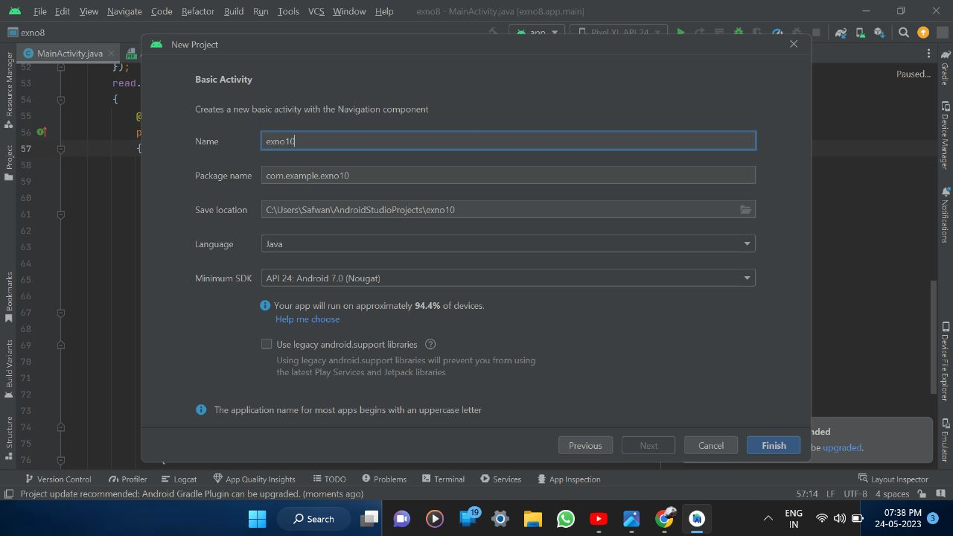



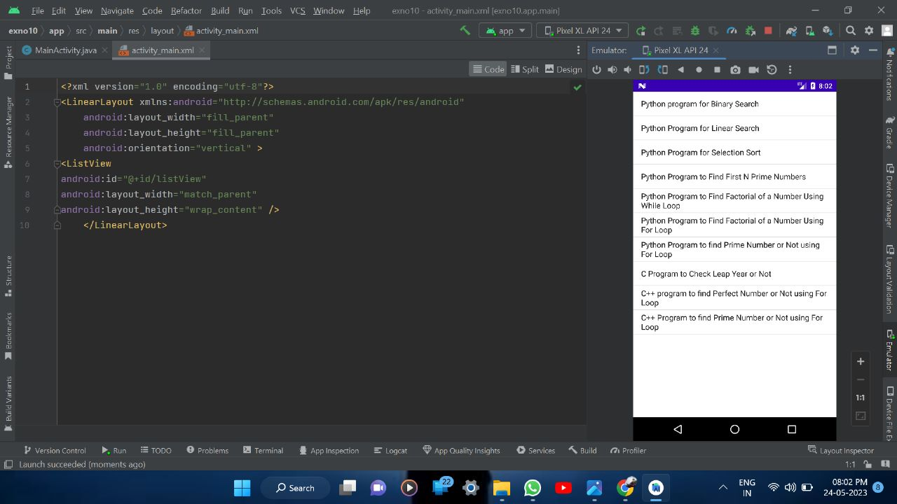

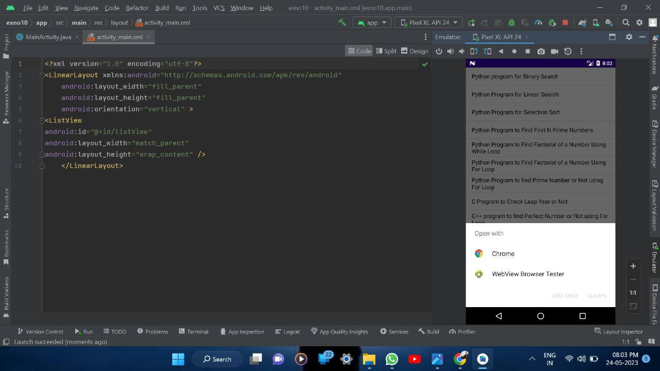**RESULT**

Thus a simple Android Application that makes use of RSS feed is designed Implemented and executed sucessfully a

**PROGRAM 11:**

**MainActivity.java**

package com.example.exno11;

import android.content.Intent;

import android.os.Bundle;

import android.widget.Button;

import android.widget.EditText;

import androidx.appcompat.app.AppCompatActivity;

public class MainActivity extends AppCompatActivity {

// define objects for edit text and button

Button button;

EditText sendto, subject, body;

@Override

protected void onCreate(Bundle savedInstanceState) {

super.onCreate(savedInstanceState);

setContentView(R.layout.activity_main);

// Getting instance of edittext and button

sendto = findViewById(R.id.editText1);

subject = findViewById(R.id.editText2);

body = findViewById(R.id.editText3);

button = findViewById(R.id.button);

// attach setOnClickListener to button with Intent object define in it

button.setOnClickListener(view -> {

String emailsend = sendto.getText().toString();

String emailsubject = subject.getText().toString();

String emailbody = body.getText().toString();

// define Intent object with action attribute as ACTION_SEND

Intent intent = new Intent(Intent.ACTION_SEND);

// add three fields to intent using putExtra function

intent.putExtra(Intent.EXTRA_EMAIL, new String[]{emailsend});

intent.putExtra(Intent.EXTRA_SUBJECT, emailsubject);

intent.putExtra(Intent.EXTRA_TEXT, emailbody);

// set type of intent

intent.setType("message/rfc822");

// startActivity with intent with chooser as Email client using

createChooser function

startActivity(Intent.createChooser(intent, "Choose an Email client :"));

});

}

}

**activity_main.xml**

<?xml version="1.0" encoding="utf-8"?>

<!-- Relative Layout -->

<RelativeLayout xmlns:android="http://schemas.android.com/apk/res/android"

xmlns:tools="http://schemas.android.com/tools"

android:layout_width="match_parent"

android:layout_height="match_parent"

tools:context=".MainActivity">

<!-- Edit text for email id -->

<EditText

android:id="@+id/editText1"

android:layout_width="wrap_content"

android:layout_height="wrap_content"

android:layout_alignParentTop="true"

android:layout_alignParentRight="true"

android:layout_marginTop="18dp"

android:layout_marginRight="22dp" />

<!-- Edit text for email subject -->

<EditText

android:id="@+id/editText2"

android:layout_width="wrap_content"

android:layout_height="wrap_content"

android:layout_below="@+id/editText1"

android:layout_alignLeft="@+id/editText1"

android:layout_marginTop="20dp" />

<!-- Edit text for email body -->

<EditText

android:id="@+id/editText3"

android:layout_width="wrap_content"

android:layout_height="wrap_content"

android:layout_below="@+id/editText2"

android:layout_alignLeft="@+id/editText2"

android:layout_marginTop="30dp" />

<!-- text Views for label -->

<TextView

android:id="@+id/textView1"

android:layout_width="wrap_content"

android:layout_height="wrap_content"

android:layout_alignBaseline="@+id/editText1"

android:layout_alignBottom="@+id/editText1"

android:layout_alignParentLeft="true"

android:text="Send To:"

android:textColor="#0F9D58" />

<TextView

android:id="@+id/textView2"

android:layout_width="wrap_content"

android:layout_height="wrap_content"

android:layout_alignBaseline="@+id/editText2"

android:layout_alignBottom="@+id/editText2"

android:layout_alignParentLeft="true"

android:text="Email Subject:"

android:textColor="#0F9D58" />

<TextView

android:id="@+id/textView3"

android:layout_width="wrap_content"

android:layout_height="wrap_content"

android:layout_alignBaseline="@+id/editText3"

android:layout_alignBottom="@+id/editText3"

android:text="Email Body:"

android:textColor="#0F9D58" />

<!-- Button to send email -->

<Button

android:id="@+id/button"

android:layout_width="wrap_content"

android:layout_height="wrap_content"

android:layout_below="@+id/editText3"

android:layout_alignLeft="@+id/editText3"

android:layout_marginLeft="76dp"

android:layout_marginTop="20dp"

android:text="Send email!!" />

</RelativeLayout>

**OUTPUT**

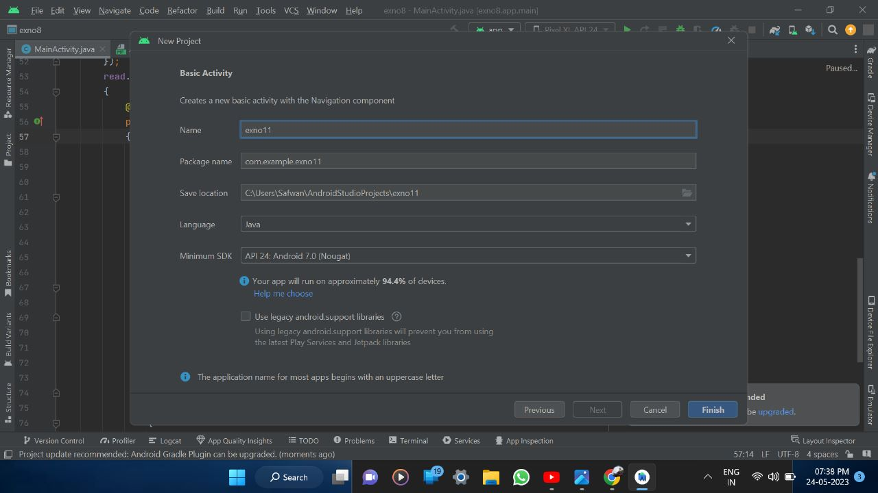



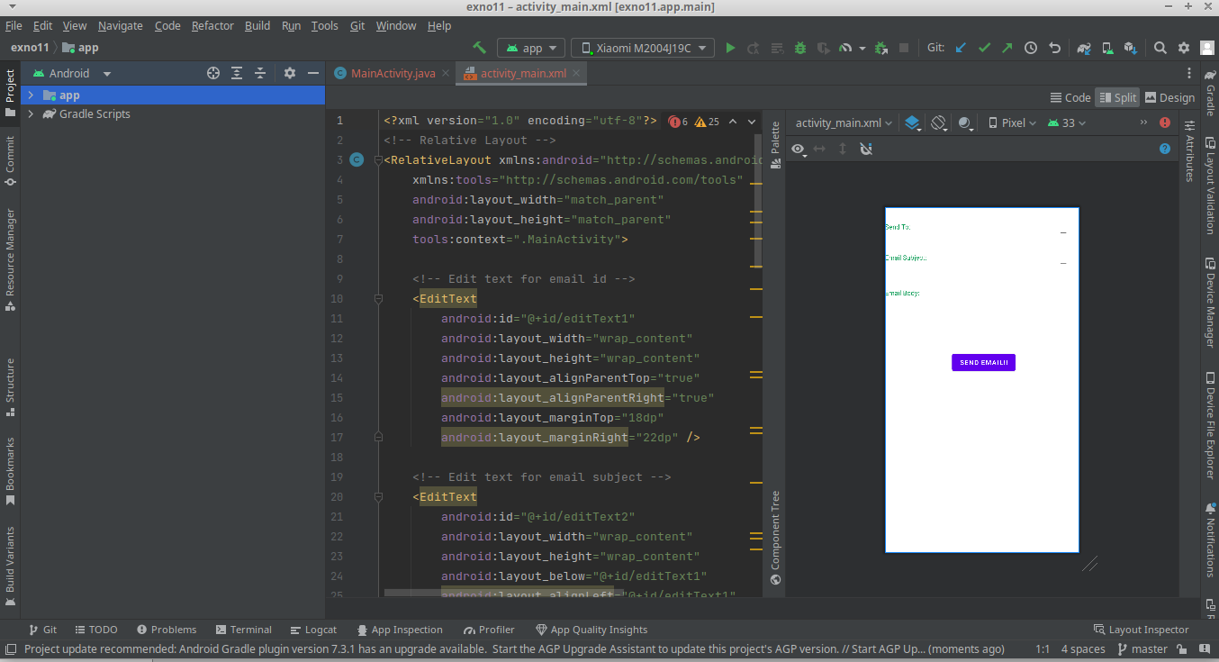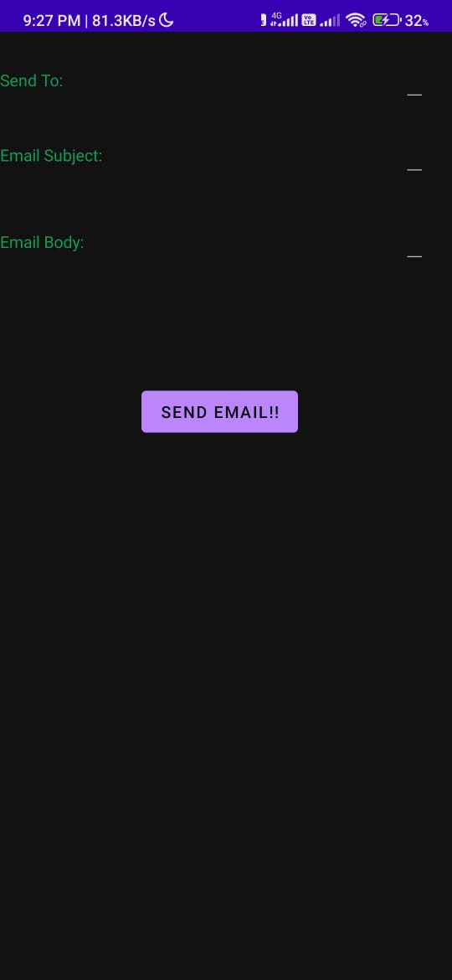

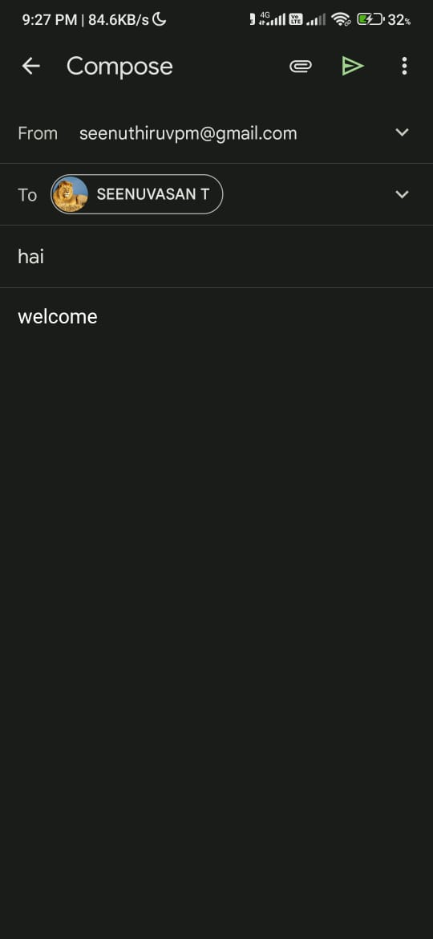

**RESULT**

Thus a simple Android Application that to send an email is designed Implemented and executed sucessfully a

**PROGRAM 12 :**

**MainActivity.java**

package com.example.exno12;

import android.os.Bundle;

//import android.support.v7.app.AppCompatActivity;

import android.text.TextUtils;

import android.view.View;

import android.view.View.OnClickListener;

import android.widget.Button;

import android.widget.EditText;

import android.widget.TextView;

import androidx.appcompat.app.AppCompatActivity;

public class MainActivity extends AppCompatActivity implements OnClickListener

{

//Defining the Views

EditText Num1;

EditText Num2;

Button Add;

Button Sub;

Button Mul;

Button Div;

TextView Result;

@Override

public void onCreate(Bundle savedInstanceState)

{

super.onCreate(savedInstanceState);

setContentView(R.layout.activity_main);

//Referring the Views

Num1 = (EditText) findViewById(R.id.editText1);

Num2 = (EditText) findViewById(R.id.editText2);

Add = (Button) findViewById(R.id.Add);

Sub = (Button) findViewById(R.id.Sub);

Mul = (Button) findViewById(R.id.Mul);

Div = (Button) findViewById(R.id.Div);

Result = (TextView) findViewById(R.id.textView);

// set a listener

Add.setOnClickListener(this);

Sub.setOnClickListener(this);

Mul.setOnClickListener(this);

Div.setOnClickListener(this);

}

@Override

public void onClick (View v)

{

float num1 = 0;

float num2 = 0;

float result = 0;

String oper = "";

// check if the fields are empty

if (TextUtils.isEmpty(Num1.getText().toString()) ||

TextUtils.isEmpty(Num2.getText().toString()))

return;

// read EditText and fill variables with numbers

num1 = Float.parseFloat(Num1.getText().toString());

num2 = Float.parseFloat(Num2.getText().toString());

// defines the button that has been clicked and performs the corresponding

operation

// write operation into oper, we will use it later for output

switch (v.getId())

{

case R.id.Add:

oper = "+";

result = num1 + num2;

break;

case R.id.Sub:

oper = "-";

result = num1 - num2;

break;

case R.id.Mul:

oper = "*";

result = num1 * num2;

break;

case R.id.Div:

oper = "/";

result = num1 / num2;

break;

default:

break;

}

// form the output line

Result.setText(num1 + " " + oper + " " + num2 + " = " + result);

}

}

**activity_main.xml**

<?xml version="1.0" encoding="utf-8"?>

<LinearLayout

xmlns:android="http://schemas.android.com/apk/res/android"

xmlns:tools="http://schemas.android.com/tools"

android:orientation="vertical"

android:layout_width="match_parent"

android:layout_height="match_parent"

android:layout_margin="20dp">

<LinearLayout

android:id="@+id/linearLayout1"

android:layout_width="match_parent"

android:layout_height="wrap_content"

android:layout_margin="20dp">

<EditText

android:id="@+id/editText1"

android:layout_width="match_parent"

android:layout_height="wrap_content"

android:layout_weight="1"

android:inputType="numberDecimal"

android:textSize="20sp"

android:hint="number 1"

tools:ignore="SpeakableTextPresentCheck" />

<EditText

android:id="@+id/editText2"

android:layout_width="match_parent"

android:layout_height="wrap_content"

android:layout_weight="1"

android:hint="number 2"

android:inputType="numberDecimal"

android:textSize="20sp" />

</LinearLayout>

<LinearLayout

android:id="@+id/linearLayout2"

android:layout_width="match_parent"

android:layout_height="wrap_content"

android:layout_margin="20dp">

<Button

android:id="@+id/Add"

android:layout_width="match_parent"

android:layout_height="wrap_content"

android:layout_weight="1"

android:text="+"

android:textSize="30sp"/>

<Button

android:id="@+id/Sub"

android:layout_width="match_parent"

android:layout_height="wrap_content"

android:layout_weight="1"

android:text="-"

android:textSize="30sp"/>

<Button

android:id="@+id/Mul"

android:layout_width="match_parent"

android:layout_height="wrap_content"

android:layout_weight="1"

android:text="*"

android:textSize="30sp"/>

<Button

android:id="@+id/Div"

android:layout_width="match_parent"

android:layout_height="wrap_content"

android:layout_weight="1"

android:text="/"

android:textSize="30sp"/>

</LinearLayout>

<TextView

android:id="@+id/textView"

android:layout_width="match_parent"

android:layout_height="wrap_content"

android:layout_marginTop="50dp"

android:text="Answer is"

android:textSize="30sp"

android:gravity="center"/>

</LinearLayout>

**OUTPUT**

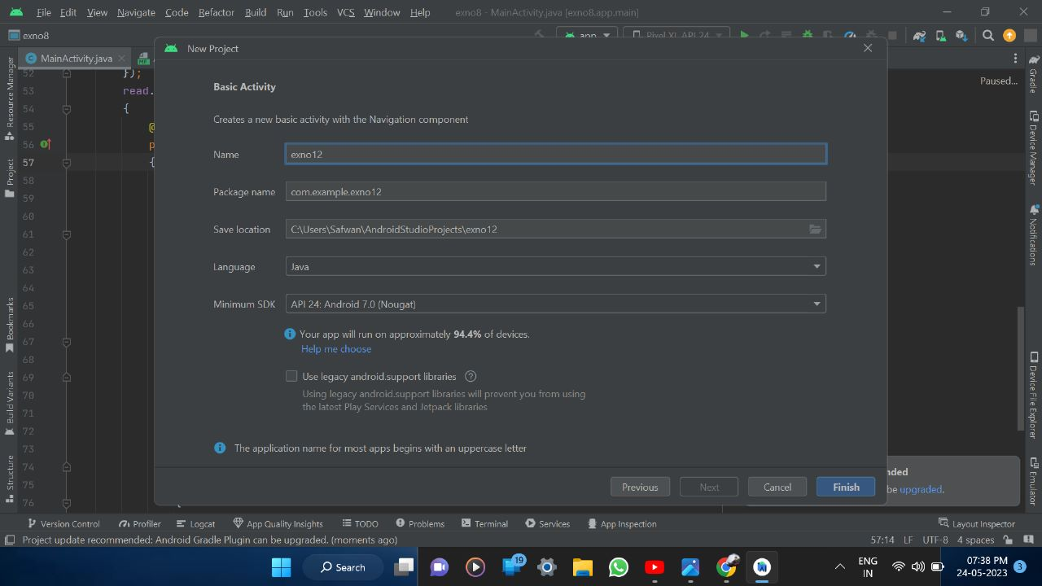



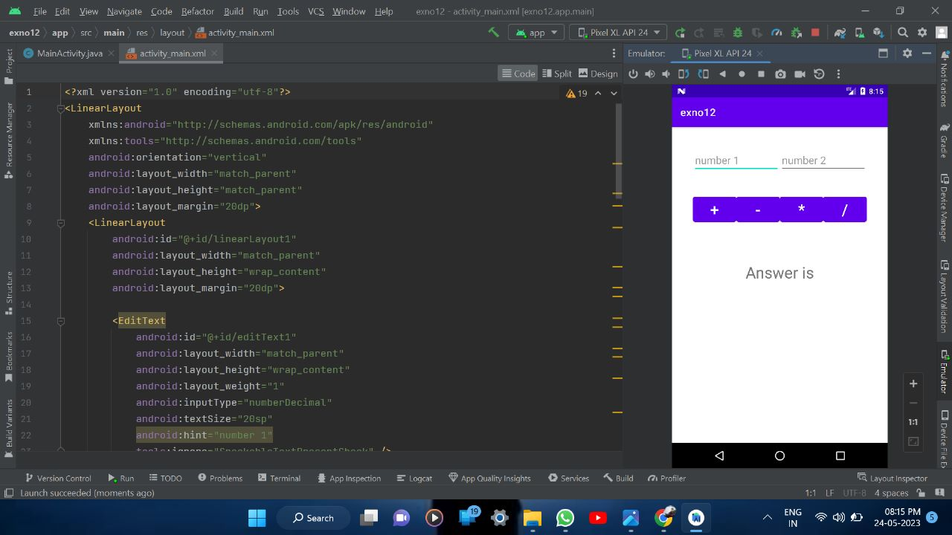

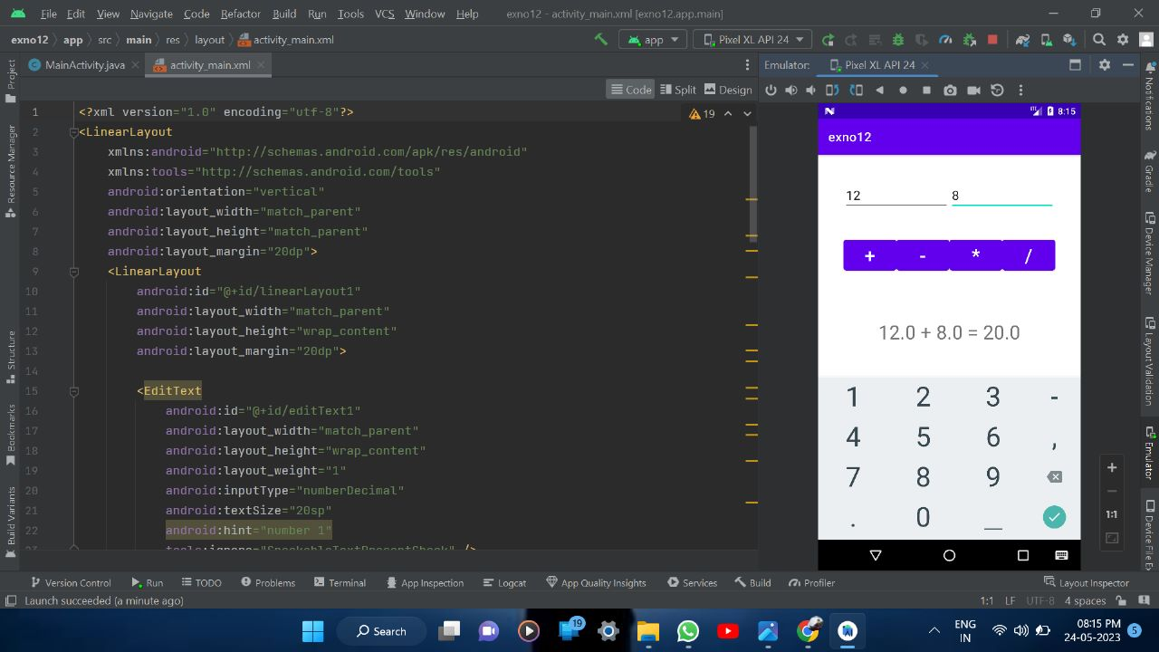 **RESULT**

Thus a simple Android Application that tfor simple needs (calculator app) is designed Implemented and executed sucessfully